# **A Spatial and Temporal Analysis of Missing Incidents**

A dissertation submitted to The University of Manchester for the degree of MRes Criminology (Social Statistics) in the Faculty of Humanities

[2021]

[10168451]

School of Social Sciences

Contents

**A Spatial and Temporal Analysis of Missing Incidents** 1

List of Tables and Figures 4

Abstract 5

Declaration 6

Intellectual Property Statement 7

Acknowledgments 8

Intro 9

Pre-Theoretic Overview 9

Aims and Objectives 10

Literature Review 11

How Do We Define ‘Missing’? 11

How Qualitative Research Has Contributed to The Study of Missing Persons 13

The Importance of Spatial Analysis and Environmental Criminology 15

Police Responses to Missing Persons 16

The Direction of Future Research 17

Research Questions: 18

Methods 19

Datasets 19

Measures 20

Study Area and Unit of Analysis 20

Variables 20

Models 21

Limitations 22

Ethics 23

Results: 24

Overview of data 24

Theme 1: Explanatory 25

Spatial Distribution 25

Temporal Distribution 30

Covid-19 34

Theme 2: Police response 35

Theme 3: Neighbourhood covariates 47

Deprivation: 47

Mental Health 52

Discussion 56

Conclusion 58

References 59

Appendix: 64

Appendix A - Urban/Rural Classification 64

Appendix B – Areas outside of study area 65

Appendix C – Call Origin 66

Appendix D – Final Classification 67

# List of Tables and Figures

# Abstract

Non-crime incidents account for the majority of calls received by police, with missing person reports accounting for a large proportion of these received. Research into missing persons have remained sparse especially in the field of quantitative studies, however methods such as geospatial analysis are paramount in the safeguarding of vulnerable people and in providing an evidenced based tool for public-policy and governance.

Using Calls for Service, this paper analysed 42,019 missing incidents from 2015 to 2020 across the county of Cheshire in order to provide a topographical perspective to the stories of going missing. Using temporal and spatial analysis this paper draws on three main themes; the spatial and temporal patterns, changes in the handling of police responses and the association to environmental corelates.

The findings from theme 1 indicated that there is statistically significant moderate clustering of missing incidents in the county of Cheshire. Additionally, missing incidents trends are seasonal in nature. Theme 2 exposed that most grades are marked as a priority response and are handled mainly by public-non emergency services despite policy identifying this as a responsibility of 999. There were also noticeable decline of trends following the start of Covid-19 as a result of changes to routine activities. The last theme indicated the association between areas high in deprivation and areas high in missing incidents among only urban LSOAs. Similarly, areas high in mental health issues also have a higher perveance of missing incidents, again only in urban LSOAS.

Although significant associations have been drawn between missing incidents and environmental correlates amongst space, further research should draw on the impact of demographic variables such as age and gender

# Declaration

This work is all the author’s original work unless referenced clearly to the contrary. No portion of the work referred to in the dissertation has been submitted in support of an application for another degree or qualification of this or any other university or other institute of learning.

# Intellectual Property Statement

i. The author of this dissertation (including any appendices and/or schedules to this dissertation) owns certain copyright or related rights in it (the “Copyright”) and s/he has given The University of Manchester certain rights to use such Copyright, including for administrative purposes.

ii. Copies of this dissertation, either in full or in extracts and whether in hard or electronic copy, may be made only in accordance with the Copyright, Designs and Patents Act 1988 (as amended) and regulations issued under it or, where appropriate, in accordance with licensing agreements which the University has entered into. This page must form part of any such copies made.

iii. The ownership of certain Copyright, patents, designs, trademarks and other intellectual property (the “Intellectual Property”) and any reproductions of copyright works in the dissertation, for example graphs and tables (“Reproductions”), which may be described in this dissertation, may not be owned by the author and may be owned by third parties. Such Intellectual Property and Reproductions cannot and must not be made available for use without the prior written permission of the owner(s) of the relevant Intellectual Property and/or Reproductions.

iv. Further information on the conditions under which disclosure, publication and commercialisation of this dissertation, the Copyright and any Intellectual Property and/or Reproductions described in it may take place is available in the University IP Policy, in any relevant Dissertation restriction declarations dep

# Acknowledgments

I would like to thank Reka Solymosi for guiding me throughout the writing and planning of this dissertation, her helpful guidance has made this experience enjoyable. She has also coached me as a research assistant where I have been able to adapt those skills to this paper – thank you for all the support.

I would also like to acknowledge the staff at Cheshire Police for one not only providing me with the data, but for answering any earlier questions in regards to the dataset

In addition, I would to thank my friend and fellow postgraduate student, Frances Bickerstaff, who has encouraged and supported the writing of this dissertation all virtuall over the last few months

# Introduction

In the UK, there are over 353,000 reported missing incidents each year with a missing person report recorded every two minutes (Stevenson and Woolnough, 2013). On average 61% of missing incidents involve children under 18, 57% of incidents involve males and 76% of incidents are recorded as White. Of these calls, the majority are marked as medium risk where the most prevalent reason for an adult to go missing is a result of mental health whereas in children this is classed as *unaccompanied juveniles* (Missing People Ltd, 2021).Researchers, practitioners, law enforcement and families have occupied the sole platform for the understanding of missing persons. The focus from each of these resources depend on determining certain risk factors. In criminology, risk factors are a practical tool used to reduce the likelihood of a crime happening yet in the field of missing person studies, risk factors are a theoretical tool used to predict the most likely groups of people to go missing or to be reported as missing. Due to the complexities in the study of missing persons, it has become a distinct discipline in itself as evident by the first interdisciplinary handbook (Morwitz, 2016). The handbook itself introduces a wide range of studies but can be summarised into three distinct themes. First, is the association between individual and socioeconomic factors amongst family members and friends that could contribute to an individual’s experience of going missing. Second, is the importance of biological and clinical observations. Finally, is the handling of missing person reports under an evidenced-based policing system. To date, one of the largest and inimitable studies explored the missing persons’ experiences. Using cases provided by the National Missing Person helpline, a review of 114 missing people was conducted in order to construct a typology of missing experiences – it engaged with the narratives of victims and victims’ families by suggesting that different adults motivation will affect *how long they travel for and where they go* (Biehal et al., 2003)*.* This research was intrinsic towards placing missing persons’ experiences on a continuum from unintentional absences to intentional absences, it also led to discussion around the ‘geographies of missing people’. For example, Tarling and Burrows (2004) introduced challenges in standardising operational procedures in the U.K and provided reasons for why research and policy face challenges in the understanding of missing persons. Gibb and Woolnough (2007) then introduced the first spatial profiles of individual characteristics in the prediction of missing persons experiences. Stevenson and Woolnough (2013) also addressed the importance of understanding missing experiences through examining the exact time a missing person leaves as essential in providing appropriate policing training. While spatial approaches have been well received by police, there is still ambiguity surrounding the overarching trends and patterns of missing incidents. Understanding the complete process that shapes the activity is crucial to any consideration of missing persons in society. As a criminologist, it is only right to question how far spatial studies aid our understanding of missing incidents in both the discursive platform and the practises put in place by law enforcement.

Missing persons are one of few incident types where the individual has the right to commit, i.e., the right to go missing. The ethical nature of investigations becomes a problem due to the broad considerations that are to be granted to an individual. There are many types of ‘missing’ from voluntary to kidnapping, from disappearances to accidental disappearances or from mass disaster to war crimes. The potential ethical challenges prove difficult in investigations including factors such as personal security, the family’s right to privacy and equal protection under the law (Kim et al., 2016). The first steps in understanding the ethical issues however, are determined by call handlers who first ask why and how the missing person went missing. This assessment of urgency is vital in helping law enforcement and other investigators to then determine the appropriate strategy. For example, in the U.K a grading system is put in place that prioritises calls from the most urgent to least. Although not defined as a risk-based strategy, its aim is to deliver a clear response to incidents whilst meeting the needs of the community. This is met by identifying ‘harm, opportunity and threat’ (H.O.T principle). No research has yet been conducted on the classification of missing persons incident reports that centralise the concept of urgency under the grading system, and given the high numbers that are reported yearly, it can be used to further comprehend police responses to missing person calls.

## Aims and Objectives

This paper uses Calls for Service (CFS) provided by Cheshire Police to understand the spatial and temporal patterns of missing incidents. The premise for this paper is two-fold; firstly literature on missing persons has primarily focused on the qualitative aspects that hone in on the narrative of missing people in order to shape police practise (Fyfe et al., 2015; Parr and Fyfe, 2013). Yet, there is an absence of quantitative analysis which can prove essential in the understanding of missing incident trends across time and space. The literature review will address the importance of qualitative findings in understanding the individual complexities of a case, but larger scale analysis on trends and patterns is also important to paint the full picture of missing incidents. By examining the relationships between multiple variables, we can infer whether the results can be applied to the population from which the sample was drawn, and to see if findings are representative of a population (Treiman, 2009). Through the use of robust quantitative methods, we will also be able to examine how the handling of missing incidents have changed over time providing a critical perspective on the different methods used in police and agency response. Secondly, geospatial analysis of calls for service is paramount in the safeguarding of vulnerable people by providing a decision-making tool for law enforcement, while also promoting the use of crime research. In recent years, hotspot policing has emerged as a strategy in incorporating evidence-based methods toward the reduction of crime (Weisburd, 2007). The strategy of hotspot policing is embedded in the theoretical framework of placed-based criminology where crime is known to cluster in certain areas, for example roughly 50% of criminal activity in an urban area accounts for only 5% of places (Andresen and Malleson, 2011). Moreover, this spatial concentration is typically found to be constant over time. This theory was introduced in Weisburd (2015) ‘The Law of Crime Concentration’ developed from Laub’s (2004) Chicago School of Criminology focussing on the importance of microgeographic units of analysis that allow for very small areas to be examined. In summary, the law states that this concentration of crime falls within a small bandwidth of percentages for a proportion of crime. Despites the evidence available in the importance of studying crime and place for improving policing and successful crime prevention application, it has maintained a marginal field in empirical research. The spatial and temporal analysis of missing persons can contribute to important theories into environmental crime and informed police practice.

This paper is intended to provide an exploratory analysis on a variety of specialisms from which researchers may benefit and to encourage those platforms responsible for missing incidents to consider how the methods for dealing with them can be improved. The starting point of any theory lies in identifying phenomena (Jebb et al., 2017) thus this paper aims to provide a comprehensive overview of spatial and temporal trends of missing incidents that have been overlooked in research.

# Literature Review

## How Do We Define ‘Missing’?

Since 2010 the UK Missing Person Unit (UKMPU) have provided robust descriptive statistics of missing persons’ where reports can be found via the National Crime Agency (NCA). The latest released report highlights missing person reports from 2019-2020 providing a year-on-year comparison from 43 police forces in England and Wales. There were 359,240 calls, 325,171 missing incidents and 155,211 individuals reported (UK Missing Persons, 2021). There are fewer individual reports than there are missing incidents, so how are these defined by the UKMPU? *Calls* represent the total number of calls made to a police force regarding a missing person, *missing incidents* however are classed as a single episode of a person being reported to the police, and *individuals reported* are defined as a person who has been reported missing recorded by the police. Moreover, a person can be recorded as missing on more than once incident. Immediately we are to question the efficiency of these crime statistics while drawing attention to what is known as the ‘dark figure of crime’; that is the differences between committed crimes and those reported/recorded crimes, and the gap between recorded and reported statistics. Contemporary research have studied the geographies of the dark figure proving that disparities exist across different neighbourhoods including suburban neighbourhoods, those economically declined, those with lower social grade, those areas with larger percentages of blacks and other ethnic groups, and those areas with increased levels of social trust (Buil-Gil et al., 2021). Therefore, when considering police recorded statistics, the effects of societal and environmental factors contribute to disparities in statistics questioning the reliability of statistical analysis. Overall, the UKMPU are useful in providing an overall transcript of missing persons however, a lot of the analysis can be critiqued for overrepresenting ethnic minorities in certain areas. Additionally, year-to-year comparison remove the possibility in examining any long-term seasonal trends or short-term variation.

There is increasing ambiguity that surrounds why people go missing, how they can be found, how they are reported, how the police deal with the initial response and who the most common groups to go missing are (Taylor et al., 2019). This confusion stems from a lack of an implicit definition of ‘missing persons’ among both the police and missing persons agencies. One might ask then who the power of the definition belongs to, whether is it the people that reported them as missing or whether it belongs to those who have chosen to go missing? Wade (2000) expanded this viewpoint by asking who the absence is a problem for, whether it’s the victim themselves or those around them. However, if missing people are viewed as merely passive victims of this labelling procedure, then we are removing their independence and minimising the complex framework of missing person reports.

In 2017 this definition gained some clarity which follows in section 1(1-4) of the latest legislation (Guardianship (Missing Persons) Act 2017). It states a person is *missing* if *a) the person is absent from his or her usual residence, b) the persons absent from his or her usual-day-to-day activities* and *c) the first or second condition is met.* These conditions lie within not knowing the persons whereabouts and their inability to make decisions relating to his or her property; if so then the management of property and financial affairs are handed to the next trusted person of the victim. The definition is typically what is reflected in both literature and policy, for example the UKMPU define *missing* as anyone whose whereabouts cannot be established. Prior to January 2017 police and governmental agency had a second category known as ‘absent person’, this was defined as a person not at a place where they are expected or required to be. However, all reports then became risk accessed into four categories from high, low, medium to no apparent risk, with *absent persons* being added to the later. The definition from the 2017 Act can be critiqued as idealistic ignoring further implications of domestic law while disguising the methodological complications. To completely remove the ‘absent person’ from the legal conceptualisation of missing person results in a more narrowed definition that is removing the historical connotations associated with being ‘absent’. Heller-Roazen (2021) challenges the categories that define a *nonperson* across the legal and sociological realm by drawing on the historical meanings of the word *absent.* Islamic scholars first defined someone as *absent* when they are non-present at their residents. In Roman civil law however, being absent implied a ‘man lost from war’; the fifth century ‘Syro-Roman Law-Book’ then extended this definition to include a man leaving a married woman similar to that of Jewish Law. Collectively, an absentee was seen as “alive with the respect to his own rights, yet dead with respect to those of others” (Ibid, 2021, p. 25), translating to mean the rights of a missing person is their own and will not be removed (unless a child or ‘insane’). Islamic law then was the first to grant a presumption of death after a certain number of years, that would then allow for the rights to be passed on. Italian lawyers also soon adopted this law. However, following the Napoleonic code it was agreed that absence never *grants the certainty of death.* Since then, this definition has remained similar.

The history of the word ‘absence’ holds a powerful image in law; it is intertwined with misogynistic interpretations that fail to consider the status of contemporary society. However, the integration of absent person in the definition of a ‘missing person’ seems to draw on the complications surrounding the presumption of death that reflect modern domestic law. Therefore, for the purpose of this study, Biehal’s et al (2003) definition of *going missing* will conceptualise the theoretical framework of this paper. She opposes any legal definitions and views each case as individualistic ranging from “an intentional break in contact, deliberately chosen by the missing person, to an unintentional break in contact, which is not of their choosing” (ibid, 2003, p. 2).

## How Qualitative Research Has Contributed to The Study of Missing Persons

There are multiple benefits of qualitative methods in the study of missing persons. From a theoretical perspective you are able to contextualise the reasons behind why people go missing including those repeat missing incidents that account for a large proportion of cases. But also, from a political perspective you are able to generate hypothesis about the contexts around these reasons, in order to understand the effects of police interactions.

Parr and Fyfe (2013) investigated the voices of returned adult missing people as a tool for establishing new emotional geographies. They critique the physical cartographies of missing journeys as predictive and fail to capture the narratives of all interpretations of going missing, including the missing voices, missing mobilities, missing experiences and absentees. The research questions why the only bit of evidence used in the journeys of missing peoples to the police are those from quantitative studies, such as the use of spatial profiles to search and locate a missing person based (Shalev Greene et al., 2009), that are however based on unstable data, inaccurate measured incidence and are too focused on categorising risk rather without referencing the individual experience. One might argue that quantitative research does indeed ignore the individual voices and instead uses the advantages of large-scale analysis to produce results that are representative of a larger population whereas qualitative studies allow for the narratives of individual voices to come to light. If geographers do indeed ‘forget’ certain groups of missing people, then an introduction of a mixed-method approach would be beneficial in including both the individual voices and the geographical analysis to understand the ‘drivers for absence’ (Edkins, 2011). In Fyfe’s later work (2015) they adopted a thematic grounded approach from deconstructing interviews from 21 key officers. From the interviews they summarised the importance of police understanding in the spatial parameters of missing persons which can only be maintained through the interplay between policing, society and space (Fyfe, 1991). In summary, the ideas of space and place are necessary in understanding the methods of investigating missing person cases. However, these ideas surrounding space and time have been based on the experiences of only a small sample of officers resulting in interviewer bias and a lack of generalisability. The ideas of space and place alone are not enough to understand missing person cases, but the physical investigation of space and place through quantitative methods could contribute to the understanding of investigatory practise (Hickman et al., 2014). Overall, Fyfe’s (1991; 2013; 2015) body of research have drawn up a discursive platform that has helped to portray the complexities of going missing, but it can only be truly understood by developing a critical-social geographical research agenda.

Quantitative studies allow for increased versatilities of research to be conducted. For example Sowerby et al (2017) used contact-based data to explore the prevalence of mental disorders of missing persons and to explore types of contact with police. Through linking individual level data across police reports and mental health services they were able to draw on a statistical association between 183 missing persons and mental health, comparing the rates with those in a random community sample. They concluded that both males and females were overrepresented as perpetrators and as victims of crime, while also having increased psychiatric morbidity compared to the general community. Substance abuse disorder was the most predominant mental disorder for both males and females. Moreover, mental health issues are also more likely correlated to adult missing persons, whereas children are more likely to contribute to repeat statistics (Henderson et al., 2000; Hirschel and Lab, 1988). Although this paper draws on difficulties surrounding the nature of missing persons its use of a small sample size is no bigger than what is used in some qualitative studies. For example, Biehal’s (2003) research found very similar results with more than 39% of their sample reporting a health problem in both adults and children, many suffering from depression or suicidal thoughts. Some unintentional absences were also linked to mental health issues. Additionally, most quantitative studies end up using police recorded statistics to analyse adult missing person among which are heavily critiqued for lacking inter-rater reliability. Qualitative research has however allowed to study the effects of police interaction at the first stages of police reporting where specific subgroups can become isolated. Research found that women reported missing tend to be re-categorised into being ‘absent’ rather than ‘missing’ as a result of a male dominated police force that participate in a form of quiet activism (Stevenson et al., 2017). We can therefore use this understanding of a female narrative as an instrument that aims to grasp the importance of gendered frames that dominate the power dynamic and underlie general mobility patterns. Although this study is beneficial as it offers a nuanced learning platform about practised reality in the police force, it’s based on a single case study that cannot generalise these results to all missing women. One might argue that there are too many complications in the study of missing persons that do not allow for generalisability to be effectively managed in both qualitive and quantitative studies (Flyvbjerg, 2006), however the study of missing persons could benefit from expanding to data rich methods which are fundamental in the understanding of trends among time and space.

## The Importance of Spatial Analysis and Environmental Criminology

Kawachi (1999) argued that relative deprivation and collective efficacy of the societal environment influence the level of crime. The root of criminology stem from the viewpoint that crime is most noticeable in those societies with large material disparities and decreased ‘quality of life’. There are multiple theoretical disciplines of criminology that highlight the link between inequality and crime. For example, Merton’s (1968) theory of anomie posits that increased status inconsistency among the social condition will influence the likelihood of deviant behaviour. Kennedy (1998) tested this theory and found relative deprivation was a strong predictor for state-level homicide rate. Chicago School researchers developing social disorganisation theory have also addressed the association between social cohesion and high crime rates. Shaw and Mckay (1942) for example, demonstrated how consistent contextual factors such as the urban landscape and population compositions of disadvantaged communities have on the high crime rate. Social capital then emerged from this field indicating that individuals can yield reproductive benefits from any feature of a social relationship (Coleman, 1990; Sampson, 1995). These studies are consistent in highlighting the association between inequality and violent crime in criminological literature (Messner, 1989). However, the fundamental issue within these theories is the narrowed focusses on just *violent* crime as they fail to consider non-crime trends, including hate crime, traffic violation, domestic abuse and missing persons. Non-crimes take up a considerable amount of money and time in police responses, yet they receive the least attention in literature. Missing person investigations have been estimated at £2000 for just those median-risk cases or £700 million each year in the U.K (Shalev Greene and Pakes, 2013). What’s even worrying is that non-crime trends make up a large proportion of the vulnerable population, and it is therefore important to question how deprivation and inequality statistics are understood in the physical environment of non-crime trends of missing incidents.

One area of criminology and social science that lacks its place in the study of missing persons is that of spatial analysis and environmental criminology. These theories state that the occurrence of criminal events can only be understood as the intersection of offenders, victims and criminal targets that occur at specific times and places. Criminality is typically an innate phenomenon that occurs as a result of biology or developmental experiences and where the prevention of crime is viewed in terms of adapting the offenders fundamental criminality through adapting behavioural changes (Wortley and Townsley, 2016). However, environmental criminology views the offender as just one part of the equation of a criminal event where the focus is on the current dynamics of crimes. The theoretical background of environmental criminology is based on three premises. Firstly, environments are criminogenic in nature, secondly the distribution of crime in space and time is non-random and lastly true crime prevention can only happen from understanding the role of these criminogenic environments (Sleeuwen et al., 2021). By understand how the socio-cultural environments moves in parallel with missing incident trends we can start to question how trends are influenced by a person’s spatial environment. An extension of this approach is the spatial-temporal context, or crime pattern theory, which helps explain crime templates that reflect target/victim assessment and explain the activity of spaces based on routine daily activities. Criminal activity has been embedded in routine activity theory where changes in people’s normal activities have longstanding changes in society, but more specifically changes to crime rate (Cohen and Felsen, 1979). Changes to routine activities can affect both temporal and spatial patterns. If a population experiences changes in routine activities at different time periods, then there will be changes to target suitability and guardianship (de Melo et al., 2018) for example in the winter months we expect to see reduced residential burglary as more people are at home (Vilalta and Fondevila, 2021). The spatial crime patterns are also affected differently due to changes in routine activities because regular changes in activities leads to regular changes in the time spent at places. Covid-19 provides an example of how temporal and spatial patterns have changed as a result of changes to normal routine (Felson et al., 2020; Langton et al., 2020). Through restricted mobility patterns and strict rules more people were required to work and educate from home. Although not a main focus of this essay, it is important to note what effect the pandemic has had on the rate of missing incidents. Additionally, the pandemic has created unique challenges for policing in the UK with new tasks including the protection of vulnerable citizens and the correct enforcement of government restrictions.

## Police Responses to Missing Persons

Newis (1999) offers an extensive summary regarding the police response to missing persons. The biggest challenge being that control room staff are pressured to collect relevant information under a given time frame. Although this review lacks temporal validity, there are parallels to contemporary policing within the methods of risk management despite that 38.5% of missing persons reported in 1997-1998 had been cancelled with ‘non-reason’ or ‘non-statement’, whereas only 17% of calls were returned by police (Morewitz, 2016). One might question why is this figure so low? Research in the sociological, psychological and economical fields have provided some possible explanations including the breakdown of family relationships, a lack of personal motivations, poor mental health and institutional short comings (Douglas and Ney, 1998; Stevenson and Thomas, 2018; Thorsen et al., 2020). However, all studies concluded that the reasons for *why* people go missing, extend beyond the knowledge of call handlers and police officers. However, if control room staff face the biggest pressure in dealing with reports as stated by Newis (ibid, 1999), then there is significant misunderstanding towards the effect that calls handlers might have on the outcome of missing person cases. Heap’s (2016) research extends this discussion by examining the call handling and management of vulnerable and repeat Anti-Social Behaviour (ASB) victims. The paper involved accessing the management of repeat calls across 8 police forces, which exposed the inconsistency of call management across not just the U.K but also among smaller areas that receive different responses due to how complaints were managed. Arguably, this could be a resource allocation issue dependent on the rural and urban geography of the police forces, it is thus wise to consider how ASB victims are being diminished by their geographical locations. This same concept can be applied to the wide variation of call management that is reflected in the differences in functionality The gap between enforcement priorities and public perceptions is sparse where the levels of police effectiveness taken at the preliminary stage of reporting is misunderstood (Squires, 2006).

In Newis’s (2005) later works, focussed turned to the importance and position of police risk assessments in the prioritising of those missing persons most at risk; generally, this is defined by grading each call from least to most at risk. Contemporary criminology has long noted the importance of risk- based prevention (Farrington et al., 2012) however, this method becomes difficult in the conceptualisation of victims, one might argue that a risk based approach to missing persons excludes there position within restorative justice by diminishing their identity to a statistic (Maglione, 2017). Donoghue (2013) suggests that victim engagement is necessary toward the development of risk assessment practises and in redefining professionals understanding of vulnerability. Future policy needs to shift towards understanding the processes of risk management in order to understand its effect on the status of missing person reports. This is seen in Greater Manchester’s Polices’ *incident response policy* (2017)that uses a graded system based on the urgency of response time; this could be seen as successful in the reintegration of missing persons definition. Calls handler typically decided the grading decision, where each decision is based off the available information from the call.

## The Direction of Future Research

Research on police resource management has predominately only used reported crime statistics, however governmental policy and academic literature describe the use of statistics as inadequate and fails to consider the collective nature of non-crime trends (College of Policing, 2015; Wilson, 2012). Additionally, recent austerity cuts to the police forces across the U.K has led to an increased public demand on policing departments, especially for non-criminal behaviour that represent a large proportion of the vulnerable population and account for 80-90% of calls (Boulton et al., 2017). It is thus necessary to understand the implications and patterns in call handling techniques to recognise its effects on community engagement and policy. The variance in reports of missing incidents feeds into the disparity of ineffective training within call handling.

One way to understand the inconsistencies within missing incidents is to further develop the geographies of missing persons. Spatial behaviour profiling has helped to improve the understanding of missing person incidents. However, these type of evidence-based policing remains new in the knowledge of ‘what works’ policing. Stevenson (2013)drew on this limitation, focussing specifically on the missing experiences that are bounded by family-police interaction. They believed that for police to respond with respect to missing situations, knowledge needs to be situated within embodied evidence. For this study they adopted a case study approach interviewing 104 persons including returned missing people, family members of the returned missing people and local police officers in order to expand search strategies for missing adults. The key finding being that both search and rescue teams, and police focus too heavily on the linear relationship of “police search being focussed on departure and destination locations, rather than journey experience, mobility and encounters” (*ibid,* 2013, p. 132). The study also found that 46% of individuals stayed local, additionally men and women both used the natural and built environment to hide. This research has helped recognise the geographical journeys of missing persons through the involvement of effective police-family interaction. The use of secondary data is now commonly available to replicate studies as above where GIS and spatial analysis research can now adopt a more nuanced perspectives of missing incidents that incorporates the benefits of evidenced-based policing. It is therefore important to combined research with training, considering the transition to an evidenced-based agenda for policing in the last decade, as necessary in order to bridge the gap between research and action.

# 

# Research Questions:

This paper provides a detailed exploratory analysis of missing incident trends across time and space, as well as addressing how police responses have varied over the last five years. The questions analysed in order to understand these trends are split into three main themes;

1. Spatial and Temporal Patterns
   1. Are there spatial patterns in missing incidents?
   2. Are there temporal patterns in missing incidents?
   3. What did Covid-19 mean for missing incidents?
2. Police responses
3. What emergency services handle the most urgent calls?
4. What percentage of calls are recorded as ‘absent, missing or other’ across i) Call Origin and ii) Grade?
5. How has the handling of missing person changed from 2015-2020 among i) Call Origin ii) Grade, iii) Final Classification and iv) Attendance Rates
6. What percentage of calls are responded to and how do they dependent on i) Call Origin, ii) Grade and iii) Final Classification?
7. How does median response time vary across Grade?
8. Environmental and Neighbourhood Covariate
9. Is there an association between rate of missing incidents and area-level deprivation, and how do these vary across rural/urban LSOAs?
10. Is there an association between rate of missing incidents and mental health at the neighbourhood level, and how do these vary across rural/urban LSOAs?

# Methods

## Datasets

A total of 6 datasets were used in the analysis with the first being the Calls for Service (CFS) data containing all calls made to the police in the County of Cheshire from 2015 to 2020. It includes 74 different incident types with information on geographical, descriptive and time-date variables. The CFS data provides placed-based statistics that can be used to study the spatial structures of a population that are largely vulnerable to both societal and environmental factors (Parr and Fyfe, 2013). It also creates an opportunity to examine how police departments responses to have varied over the last 5 years (Makin et al., 2021). Using this method of data-collection from 2015 will allow for the effects to be situated in real-world behaviour promoting generalisability (Warner and Pierce, 1993). Moreover, with a wide timeframe more robust methods of analysis can be used that allow for the temporal trends, noise and spatial patterns to be explored in the reports of missing incident (Weston et al., 2019) .

The second and third datasets were obtained from the *open geography portal.* The first being the lookup table for the LSOA names and codes in England and Wales 2011. These were added to the CFS data as they only contained the LSOA names. The second dataset collected from the portal were the rural/urban classifications of LSOAs (2011), these were again joined to the CFS dataset and provided further contextual knowledge about how missing incidents are distributed across different area. All output areas (OAs) were coded as urban if they were allocated to a 2011 built-up-area with a population of 10,000 people or more, the remaining were codded as ‘rural’. The LSOA classification is based on the aggregation of OAs, but also identifies smaller hub towns with a population between 10,000 to 30,000. There were 4 types of smaller hub rural areas and 4 types of smaller hub urban areas but were grouped and recoded into a binary variable representing just rural and urban areas due to missing values (*See Appendix A, Table 1*). These will help represent the spatial regimes in the spatial regression models.

The fourth datasets were population statistics also obtained from the Census 2011, specifically obtaining the residential population, the workday population and total LSOA population

in order to compare the effects of different population rates of missing incidents. The residential population reflect the usual activity of an area, whereas the workday population reflect the people who work, those who are resident in the area and those that either work from home or who do not work (Reis et al., 2018). Workday and residential population are however limited as they do not include activities other than employment. Therefore, the total LSOA population represent a more regular spatial grid (Malleson and Andresen, 2016) that exclude irregular population activity. The three rates were calculated by dividing the number of missing incidents by the population and multiplying by 1000. Typically, crime rate is expressed by 100,000 inhabitants but as my unit of analysis is at the LSOA level (Lower Layer Super Output Area), a rate of 1000 better represents the average population across LSOAs in the U.K. Using rate reduces statistical bias and reduces the effect of the modifiable areal unit problem (Wong, 2004). Median Age was also obtained due to literature addressing important differences in age. There were 5 LSOAs in Cheshire East that did not match with the census data and produced NAs, thus imputation of the mean residential population from Cheshire East were used to fulfil the dataset (Little and Rubin, 2002).

In order to examine how environmental and neighbourhood covariates affect the number of missing incidents small area level statistics were used that measure deprivation and mental health separately. The Index of Multiple Deprivation or IMD (2019) provides area level statistics for a relative measure of deprivation across England ranking from 1 (most deprived) to 32, 844 (least deprived areas). The relative measure for LSOAs is based on seven different domains of deprivation (income, employment, education, health/disability, crime, housing and environment) and are referred to as neighbourhood-level indices. Decile scores are also provided by ranking the 32,844 LSOAs and dividing them into equal size groups from 10, where 1 is most deprived 10% and decile 10 is least deprived 10% of areas nationally.

The Small Area Mental Health Index or SAMHI (2020) also provides an annual measure of population mental health in each LSOA in England from 2013 – 2018. It combines data from multiple health sources including NHS, prescribing data (antidepressants, QQF DWP), incapacity benefit and employment support allowance into a single index. The index was individually standardised via z-scores (using mean of 0 and standard deviation of 1) to obtain the intra-correlations between all indicators. Similarly, decile scores were provided alongside the index from 1 – 10. As the IMD and SAMHI decile scores were calculated using exponential distribution, these were used for the analysis as they allow for equal comparison across populations structures.

## Measures

### Study Area and Unit of Analysis

The total amount of calls received from 2015-2020 were 1,749,123, with missing incidents accounting for 42,547 calls over 903 LSOAs. In the sample 528 calls were made from LSOAs which were outside the study area, so they were excluded (*View Appendix B, Figure 1).* The total sample was therefore reduced to 42,019 missing incident calls across 652 LSOAs. The study’s Unit of Analysis is the LSOA (the total number of missing incidents per LSOA from 2015-2020) and the dependent variable is the rate of missing person (n/residential population * 1000).

### Variables

11 variables from the CFS were used;

**LSOA name**: Lower Layer Super Output Areas are geographic areas used to improve small area statistics in England and Wales. They were used to create a geometric object that will explore the spatial trends of missing incidents across the four local authorities.

**Local Authority:** LAs used to help identify the boundary districts for the 4 local authorities *(view Table 1)* **Date and Times**: This variable included the year, date, month and time (hour/minute/second) and were converted to a date object that allowed to access for any temporal patterns. **Median Response Time:** In order to obtain the median response time, all calls that had been attended were selected and the difference between the *earliest deployed date time* and the *earliest arrived date time* was calculated creating a new time variable representing the average minutes it took to deploy and to arrive to a missing person call. This will help to access the similarities to the GMPs incident response policy. **Attendance:** This binary variable represents whether the call was attended or not with 1 meaning Yes and 0 meaning no. **Call Origin**: Call Origin, a nominal variable, identified the source of the call and originally included 11 categories (*View Appendix C – Table 2)* however due to low cell counts these were categorised into 5 main themes named public-non emergency, 999, Police Generated, Other Emergency Services and Unknown. **Final classification**: Final Classification, a nominal variable, identified the final description of the missing incident type, and were displayed across over 30 incident types (*View appendix D, Table 3*). However, these were categorised into just three groups representing *missing persons, absent person* and *other.* The later represents all of the incident’s types that received counts smaller than 30 to reduce noise.

**Initial and current grade**: Both grade variables are ordinal. They are used by dispatchers to represent the urgency of the call by giving a score from 1 -5. Grade 1 represent an emergence response (attendance within 15 minutes), Grade 2 is a priority response (within 1 hour), Grade 3 is a routine response (within 4 hours), Grade 4 is a scheduled response (attendance or resolution within 48 hours) and Grade 5 represent a telephone solution. Initial grade would typically relate to resource allocation, whereas current would reflect the actual response required of the call in which helped to gain an understanding toward police practices (GMP, 2017).

## Models

This paper uses a series of models to analyse underlying using the software R 4.0.4 (R Core Team, 2021) The main packages used were produced by ggplot2 (Wickham, 2016), tmaps (Tennekes, 2018) and sf (Pabesma, 2018). A full list of packages and references can be found in *Appendix E.*

**Theme 1 explores both the spatial and temporal trends of missing incidents.** Local indicators of spatial autocorrelation (LISA) maps will be used to indicate the extent to which a significant spatial clustering of homogenous values exist in the study area. LISA has two characteristics. First it provides a statistic for each location while providing an assessment of statistical significance. Secondly, it provides a statistic for the relative relationship between the sum of the local statistic and its corresponding global statistic. Spatial autocorrelation statistics combines a measure of attribute similarity between two observations, using spatial weights which act as an indicator for locational similarity. All Moran statistics are based on a *contiguity-based spatial matrix,* in this paper I use the ‘*the queens’ criteria* as it accounts for all areas in a area whereas the ‘*rook criteria’* does not include shared corners reducing the distances in our LISA maps (Anselim, 1995). The LISA maps make connection between significance and the Moran scatter plot, which give you four types of spatial autocorrelation known as high-high and low-low (hot spots and cold spots; spatial clusters) and high-low and low-high (spatial outliers). Decomposition methods will be used to access the seasonal and trend components, specifically examining seasonal variation and changes in the autocorrelation (Hyndman and Athanasopoulos, 2018). Lastly seasonal autoregressive moving average (SARIMA) models will be used to answer whether the pandemic has had an effect on the rate of missing incidents as a result of changes to routine activities. This involved forecasting data in order to make predictions about what would have happened in the absence of Covid-19 accounting for overall trends and noise (Cryer and Chan, 2008) .

**Theme 2 will analyse the changes in police responses through univariate, bivariate and advanced time-series models.** Univariate statistics examine how each characteristic of police response vary in their mean, median and range before examining the association to other variables. Bivariate analysis will help to establish which police response variables are highly correlated in the number of missing incidents. These were assessed using Chi-square to test for homogeneity (Allen, 2017). Time series models were used to highlight how police responses vary over time. The interval of time was measured at weeks as using daily counts created too much noise; these were represented using a conditional mean (Hyndman and Athanasopoulos, 2018).

**Theme 3 will use explore the effects of the neighbourhood covariates through Poisson and spatial regression model.** Negative binomial regression will provide rate ratios on how more or less common the different deciles are compared to within the deprivation statistics and within the mental health statistics (Hilbe, 2011). They are a form of Poisson regression that account for the over-dispersion of the counts of missing incidents among each decile statistics. A spatial model was required for the data due to the presence of spatial autocorrelation amongst the residuals from a linear regression. Using the Moran’s I statistic for residual spatial autocorrelation exposes any errors that are connected systematically within themselves. Therefore, it was appropriate to use a spatial regression model to study how missing incident rates varies systematically over space due to its correlation with the environmental correlates. The Lagrange Multiplier Test provided guidance on the most appropriate spatial models for both the urban and rural spatial regimes (Solymosi and Medina, 2021). In spatial regression models, the standard properties of ordinary least squares (linear regression) do not hold as it fails to account for spatial autocorrelation. This because it assumes coefficients are constant across all spatial elements, ultimately confining spatial variation to the error term (Srinivasan, 2008). Fundamentally spatial autocorrelation accounts for the level of spatial randomness; measured both through global/local estimates and spatial regression (testing for heterogeneity). Two spatial regression model were examined, one over the deprivation statistics including the median age of each LSOA and one over the mental health statistics again including the median age. From both models the urban and rural LSOAs (spatial regimes) were examined as research would indicate increased clustering in the more densely populated areas so we can test to see if this is true with the presence of missing incident rates.

## Limitations

One weakness with the CFS data is the failure to capture repeated measures reducing the opportunity to build a case review on repeat location. The UKMPU (2016) reported that 48.5% of reports are attributable to ‘repeat missing’ cases in the U.K. with a higher proportion of reports among children. For a child they will be classed as ‘repeat missing’ if they have been reported missing three times or more in a 90-day period. These repeated reports raise the issue of the duty of care and responsibilities from police forces. Although unable to study the effect of repeat missing incidents on the proportion of calls received, this paper will still address the importance of GIS in the understanding of missing incident trends and highlights the importance of quantitative studies in adding to the overall picture of missing persons. Moreover, this study is based on data from only Cheshire Police and raises questions about generalisability across other police forces, specifically in regard to differences in police response to missing incidents. This is not to say that these findings cannot resonate nationally, but should be with caution. Moreover, CFS, as with crime rate data, are still affected by reporting statistics among certain demographics of the population. Graber and Stern (2018) highlighted that to call the police is a privilege of being white, additionally police legitimacy can also affect the willingness to call the police (Taylor et al., 2015). Therefore, not all populations are likely to call the police so reports of missing incidents raise questions about reliability from our sample size. Arguably, there is no perfect measure of crime incidence but CFS provide a dataset that is not just measuring crime, but also questioning the practices police and public services.

The SAHMI dataset also has some limitations, the first being that the years do not overlap with the years in the CFS removing the possibility to examine 2019 and 2020 which may have been crucial in understanding the effect of mental health over the pandemic (Brewin and DePierro, 2020). Additioannly, its index measure is only created from four mental health sources specifically from those who receive medical help from the NHS or incapacity benefits, thus ignoring a large proportion of the population who are undiagnosed. Mental health research is challenging given the apparent limitations of both ethical principles and data-collection. Nevertheless, SAMHI offers one of the first longitudinal placed-based data resources replacing the Indices of Deprivation Mood and Anxiety. Disorders. The IMD has been used constantly in amending public policy, guiding resource distribution and has contributed to the housing markets. However, increasing literature is drawing debate on its elements of methodology that could systematically underscore the level of deprivation in big cities due to techniques such as double counting and weighting applications, but also due to the disbursement of urban police regeneration resources (Deas et al., 2003)

A large proportion of the findings in this essay are generated from Local Moran I Statistics which are bound by methodological issues. For example, the 0.05 pseudo p-value set under the Monte Carlo simulation is likely to lead to many false positives which reject the null hypothesis even when it in fact holds (Castro and Singer, 2006). This is known as the multiple comparison problem that does not hold any satisfactory solution therefore interpretation of results should be questioned outside of the study area.

* Add in limitation about IMD and census in general

## Ethics

These variables from the CFS dataset were requested as part of an N8PRP funded research project named *understanding changing demand for police during the coronavirus pandemic,* the dataset had become available due to my presence in the project as a research assistant. Following this, all ethics have been considered and approved by The University of Manchester; reference approved by *2020-11031-17216.* At conceptual level this paper and the CFS can be critiqued for its use of the definitions surrounding ‘missing’. The final categorisation variable still includes the category of absent person even though this was removed from policy in 2017, additionally many of the categories has been sub-grouped under other incident types. To reiterate, it is important to view missing persons as individual beings as contextualised by Biehal’s (2003), and not to be overlooked by statistics.

# Results:

|  |  |
| --- | --- |
| Calls for Service Variables (2015-2020) | |
| Unit of Analysis: | |
| Total: *LSOA = 652 N = 42019* | |
|  | |
| *Cheshire West and Chester:* 212 11287 | |
| *Cheshire East* 234 12082 | |
| *Halton 79 8799* | |
| Warrington 127 9653 | |
| *NA = 201* | |
| Categorical Variables: | ***Frequency (%)*** |
| Call Origin |  |
| *Pubic non-emergency* | 84.73 |
| *999* | 13.83 |
| *Other Emergency* | 0.89 |
| *Police Generated* | 0.56 |
| *Unknown* | 3.667 |
| *Initial Grade* |  |
| *1* | 4.95 |
| *2* | 83.78 |
| *3* | 4.43 |
| *4* | 6.71 |
| *5* | 0.12 |
| Current Grade |  |
| *1* | 4.77 |
| *2* | 61.13 |
| *3* | 7.62 |
| *4* | 25.96 |
| *5* | 0.33 |
| *Grade Change* |  |
| *Yes* | 68.72 |
| *No* | 31.28 |
| Final Classification |  |
| *Missing* | 86.94 |
| Absent | 5.42 |
| *Other* | 7.64 |
| *Attended* |  |
| Yes | 64.57 |
| No | 35.43 |
|  |  |
| Date and Time Variables: | |
| Earliest Deployed Date/Time: | |
| Earliest Arrived Date/Time: | |
| Median Response Time (minutes): | |
| Min:0.00, Median: 28.08, Mean: 84.87, Max: 8503.37, IQR: 51.55 (NA: 1177) | |

# Overview of data

*Table 4: Frequency Distribution of Calls-for-Service Variables*

There was an average of 64.45 calls per LSOA from 2015 to 2020 with anywhere from 1 to 763 calls made in each LSOA. In 2015 the average number of calls per LSOA was 9.92, in 2016 it was 10.78, in 2017 this was 12.15, in 2018 this was 13.55 and in 2020 this decreased to 10.86. The average rate of calls (per 1000 residential population) per LSOA from 2015 to 2020 was calculated at 40.73, ranging from 0.8 to 402.85. The rate had also increased up until 2019 and declined in 2020. The *median response time* only applies to those calls attended from 2015 to 2020 (n = 27,472), leaving a percentage decrease of 34.6%. Figure 2 also highlights the distribution of missing incidents across urban and rural LSOAS showing a higher density and higher distribution of missing incidents in the Urban LSOAs despite there being almost five times as many Rural LSOAs.

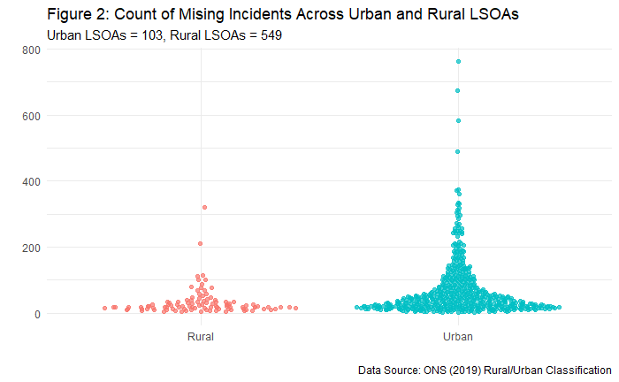

## Theme 1: Explanatory

### Spatial Distribution

Figures 3(A-D) highlights how the distribution of missing incidents differ depending on different population statistics. The results show the effects of using different denominators in the mapping of missing incidents; using just the count overestimates the trend and doesn’t account for variation in population LSOAS. Following Malleson and Anderson (2016) paper, residential population provides the best proxy for the observed population and was thus used as the main measure of rate. Map D demonstrates a fairly random distribution of rates across our study area arguably with increased rates in what looks like tighter clusters of LSOAs. LISA maps were used to study the patterns of randomness in both the count and rate trends.

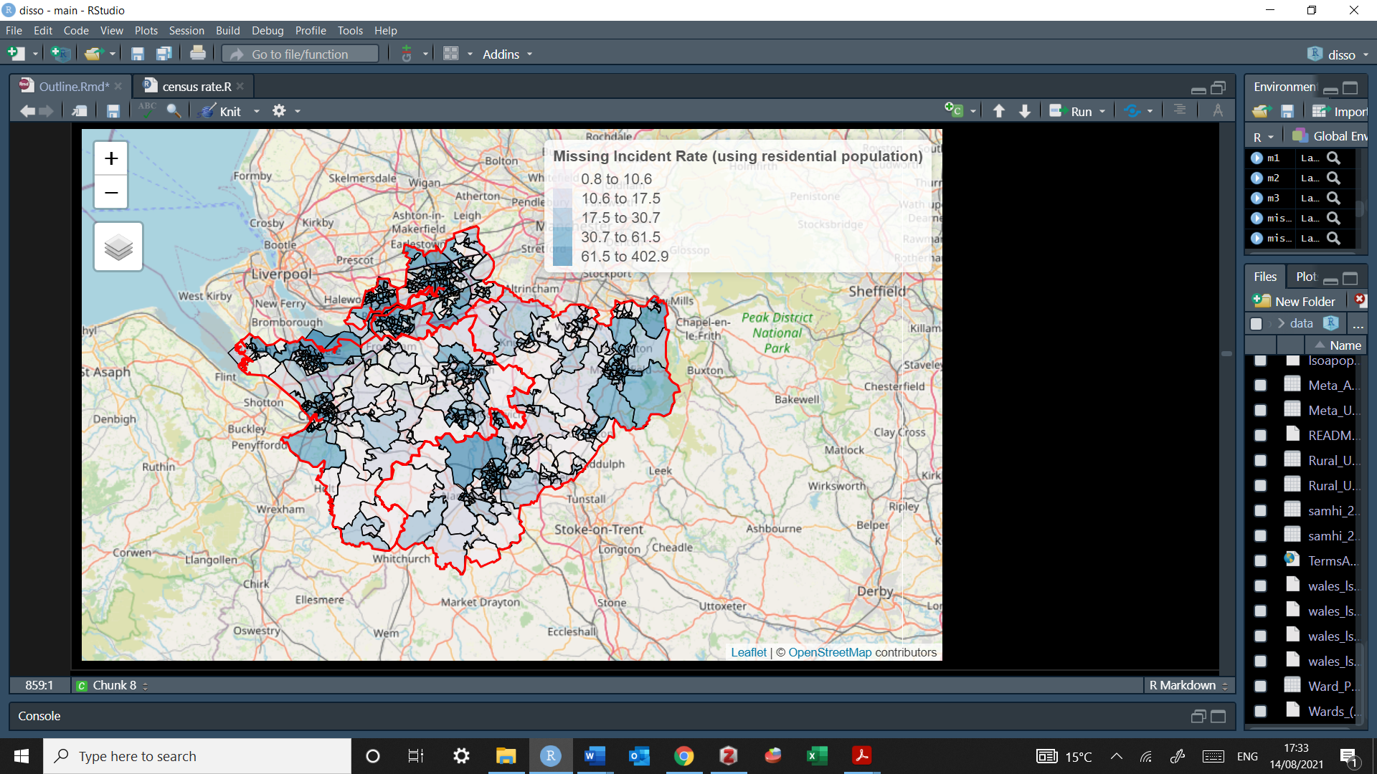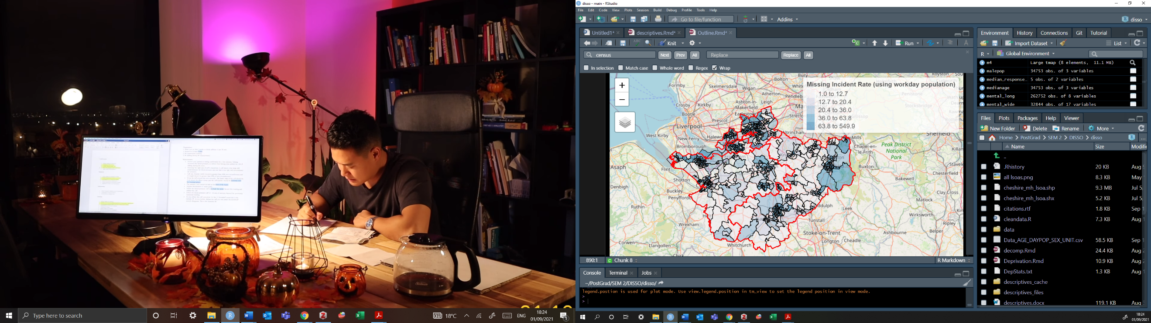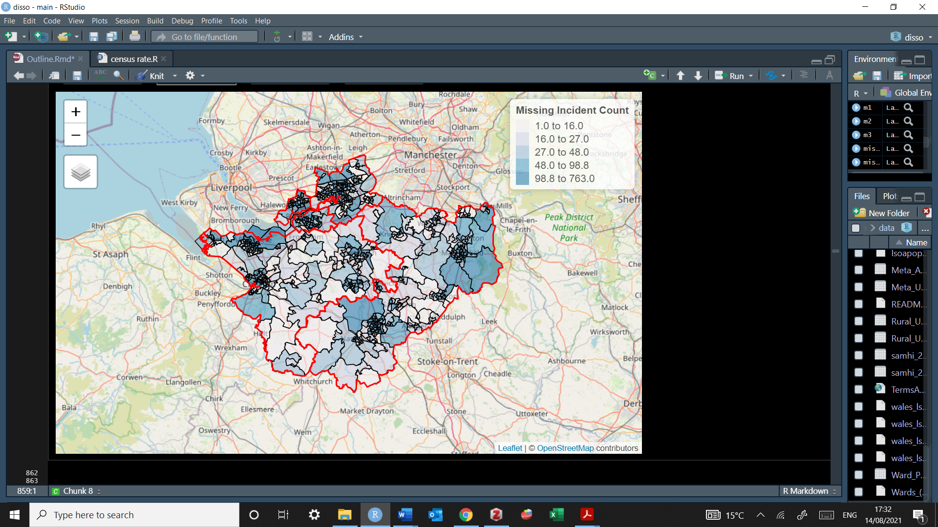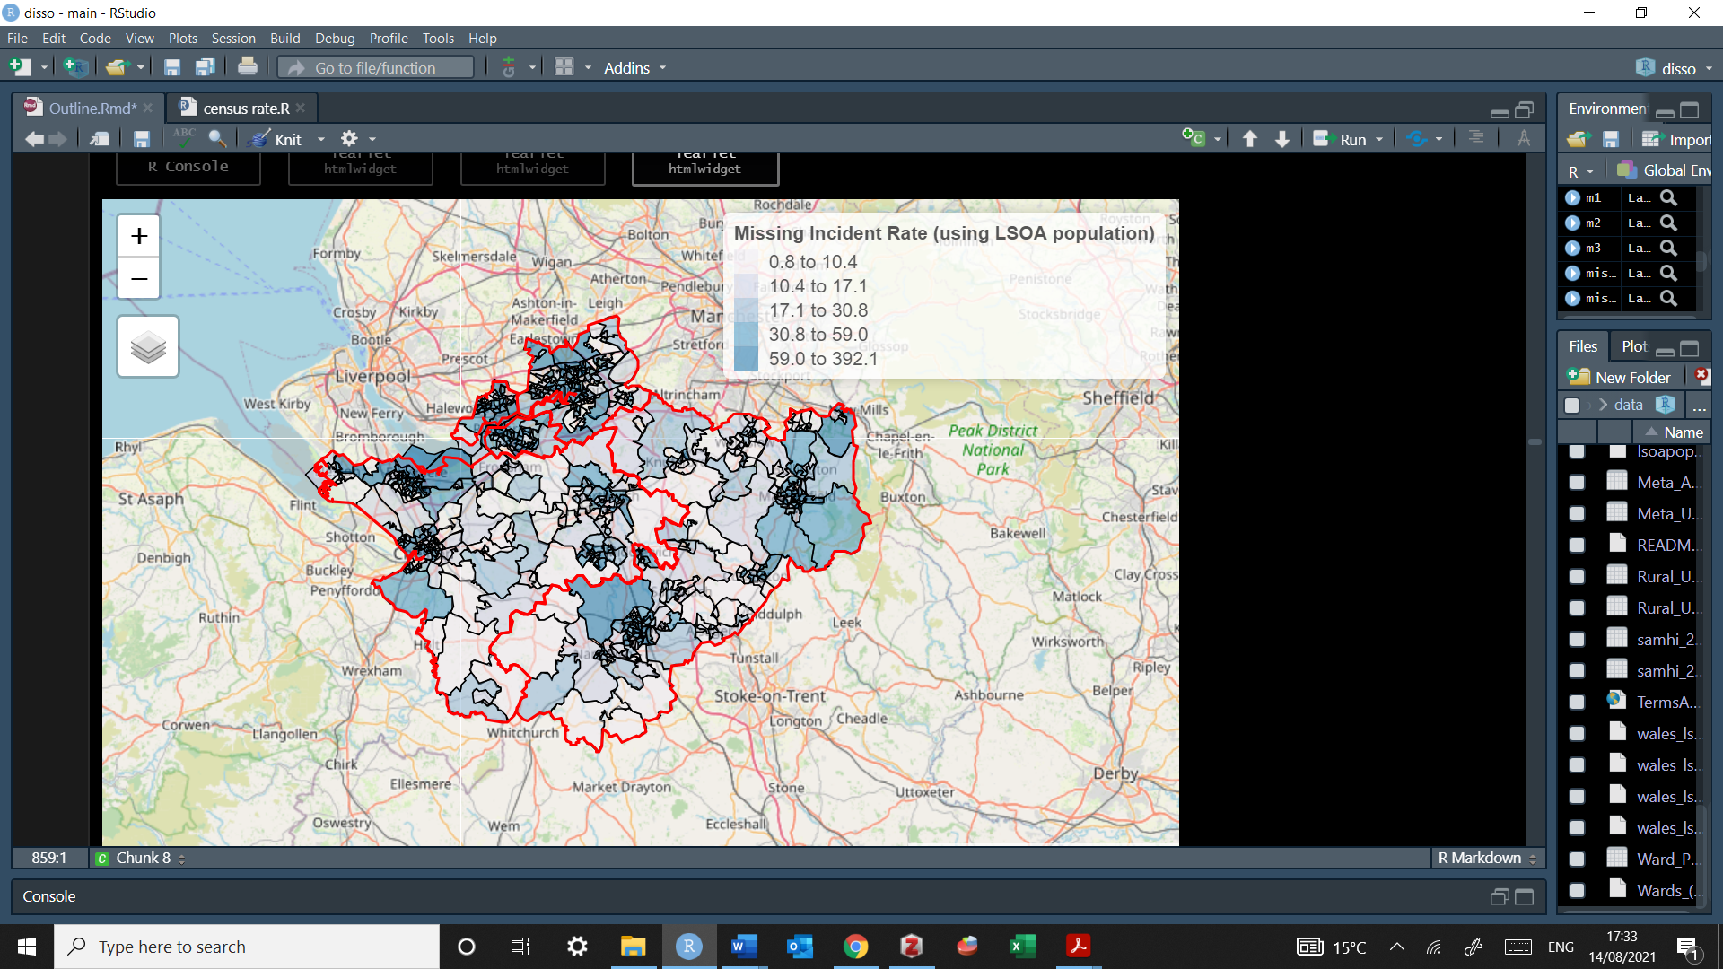

**C**

**D**

**B**

**A**

**Figure 3**(A, B, C, D) – Crime Count, LSOA Population, Working Population and Residential Population

Using the queens criteria each LSOA polygon in the study area has an average of 5.7 neighbours . Under the count data. results indicate a positive spatial autocorrelation (Moran I = 0.2463, P = 1e-05) suggesting that areas with high levels of missing incidents are associated with other areas with high levels of missing incidents. Moreover, this association is statistically significant due to the low p value indicating that the spatial processes promoting the observed pattern of values is random by chance. There are 54 high-high categories, and 598 non-significant, where 54 LSOAS have a p value under the alpha level of 0.05. The LISA map is telling us that there was some moderate clustering of missing incidents in Cheshire.

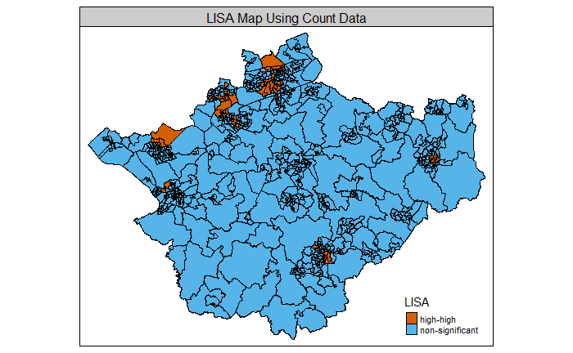***Figure 4****: LISA Maps Using Count:*

When examining the rate statistics, there is also a positive spatial autocorrelation which again means that high values cluster near other high values and low values cluster near other low values (Moran I = 0.2453, P = 1e-05). Figure 5 highlights the positive association between the spatially lagged variables and the rate in each LSOA, where the missing incident rate is plotted against the weighted average value of missing incident rate in the neighbours.

***Figure 5****: Moran Scatter Plot of Spatially Lagged Values Using Residential Population*

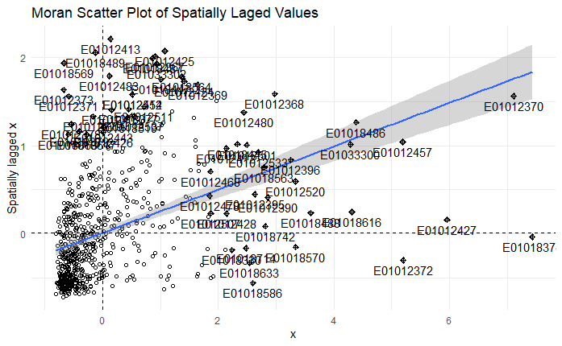

The high-high categories reduce to 52 and the non-significant increases to 600 (*Figure 6*). Although the changes are pretty small, using counts provide an over estimation of the frequency of clusters across greater the four local authorities. Therefore, missing incidents are clustered among our study area where high areas are linked to other area areas. It’s also important to note that a large proportion of the study is non-significant based on the Monte-Carlo test ( P < 0.05). This variation in spatial association exists within local area due to spatial heterogeneity. These are our spatial outliers indicating that high values are surrounded by low-values and low-values are surrounded by high values.

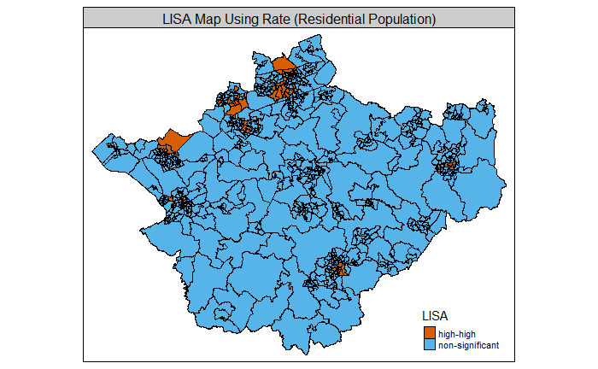***Figure 6****: LISA Map Using Rate Statistics*

### Temporal Trends

Figure 7 highlights the weekly count of missing incidents from 2015 to 2020, showing a general increasing trend up until April 2019 followed by a gradual decline. This decile was soon met with the start of a global pandemic, additionally there is increased noise in the dataset that followed by a gradual incline after the first lockdown ended. There is also some noticeable variation is, for example from the years 2015-2019 there are clear spikes of weekly counts in March, July and October, and arguable decreases in April, August and November. In order to understand whether there are random fluctuations or seasonal trends, the trends were split into a i) time plot i) seasonal plot ii) seasonal subseries and a iii) box-cox transformation. Figure 8 demonstrates these from 2015 to 2020 whereas Figure 9 excludes 2020 following the start of the first known U.K Covid-19 case.

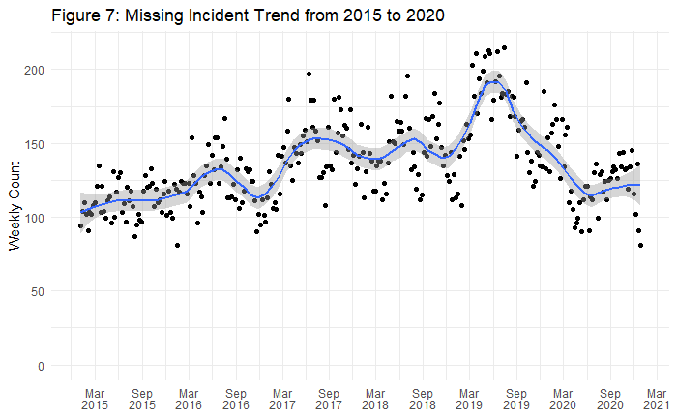

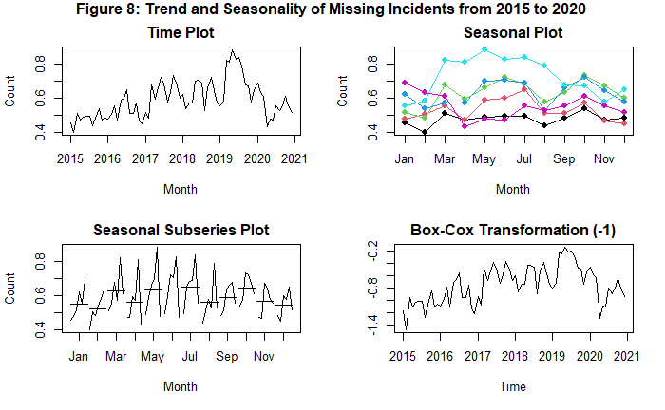

2019

2017

2018

2020

2015

2016

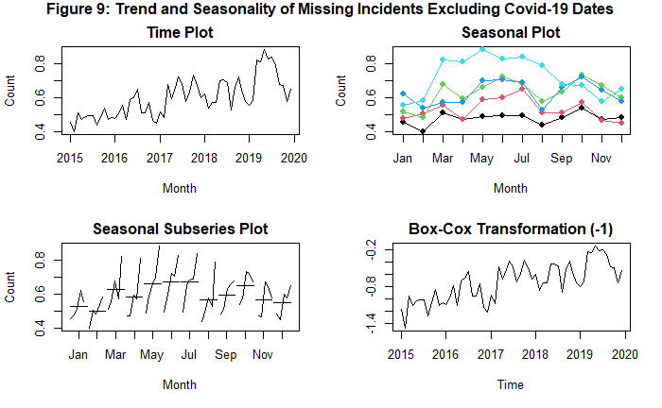

2019

2017

2018

2015

2016

Comparing pre/post covid dates gives an insight into the changes in missing person calls. The time plot represents each observed value against the time of observation. In both figure 8 and 9 the overall pattern can be described as an exponential growth, however from 2020 the counts seem to be less than expected. The seasonal plot represents each observed value against the time of the observation for a given year. From 2015 to 2019 there are some seasonal patterns with spikes in March, May and October and declines in August, however the 2020 trend does not follow these patterns. The Seasonal Subseries Plot represents each observed value against the time of the observation with separate lines connecting the observations per season per year, it also includes a line in each season representing the mean for each season. Figure 8 highlights a steep decrease at the end of each month, whereas when excluding 2020 (in figure 9) different seasonal patterns are present therefore effectively showing the underlying quadratic trend. It is important to address the changes the pandemic has had on the number of missing incident reports. Lastly the Box-Cox transformation is used to normalize data while improving forecasting through the use of a λ parameter. Both Box-Cox returns a value of λ=− 1

Using the autocorrelations (ACF), we can test how the present values of the series is related to its past values. It considers trend, seasonality and residuls while finding correlation. Autocorrelations measures the extent of a linear relationship between lagged values of a time series.

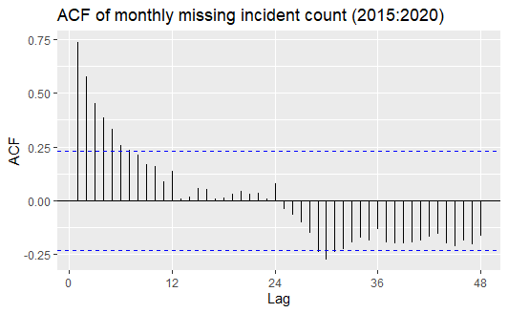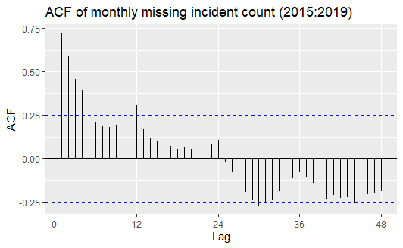***Figure 10 (A, B): Autocorrelation of missing Incident Count***

ACFs of trended time series typically show positive values that slowly decrease as the lags increases. However, the autocorrelations are larger for the seasonal lags in Figure 10(B), highlighting increased seasonality from 2015-2019. When including the pandemic dates from 2020 these seasonal lags decrease, i.e., autocorrelations are smaller in lags 12 and 24, further concluding that the pandemic has affected the rate of change for missing incidents. However, the typical ‘scallop’ shape for seasonal trends is limited in both plots, so we can split the time series into several components to understand the underlying pattern category via decomposition methods. Additionally, this will guide us to choose the right forecast method in predicting the expected trend of missing incidents following Covid-19.

#### Time Series Decomposition:

Data can either be additive (an increasing trend followed by decreased) or multiplicative (magnitude of seasonal component change with time). In this dataset we have an addictivecomponent where the variation due to seasonality is our primary interest, we do not need to seasonally adjust the data, but instead examine the trend-cycle. The X11 decomposition method was used to highlight this trend-cycle as it allows for the seasonal component to vary slowly over time. The X11 decomposition method is highly robust to outliers and level shifts in the time series (Hyndman and Athanasopoulos, 2018) .

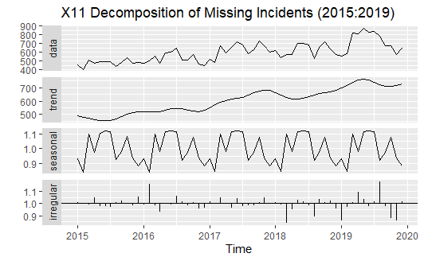**Figure 11 (A, B): X11 Decomposition of Missing Incidents**

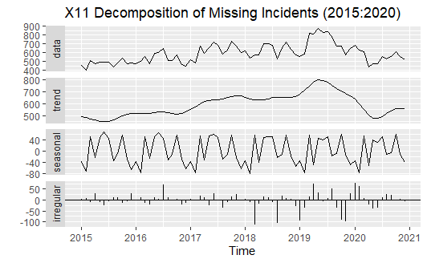

Both figures above highlight an increasing quadratic trend, monthly seasonality and fairly random residuals. When examining figure 11 (B) there is a clear upward trend and some seasonality, with the seasonal component being steady over time. therefore, when removing the effect of covid-19 missing incident can be said to be seasonal, with clearer consistent spikes in the summer and winter months. However, when examining the full dataset, the seasonal component is decreasing as the trend decreases with an increase in outliers, Additive data can also be seasonally adjusted, which will remove all seasonal patterns marked by a calendar. Figure 12 shows that the seasonally adjusted data (red) still contains the trend-cycle (grey) and the remainder components create the same the same pattern. Therefore, we can conclude that the monthly changes are in fact due to seasonal changes.

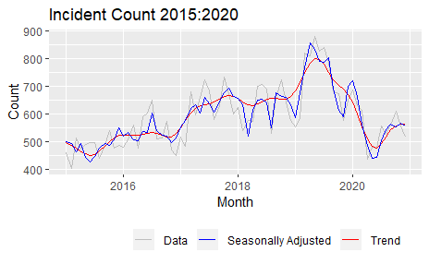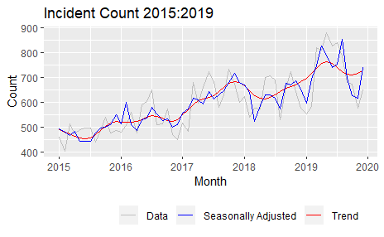**Figure 12: Missing incident count;** **the original data (grey), the seasonally adjusted data (blue) and the trend cycle components (red)**

### Covid-19

The SARIMA model provided accounts for how different the observed values of missing incidents are compared to the predicted values; the plot also provides 8 significant dates that were specific to our study area over COVID-19. The results support findings from Green’s (2020) study highlighting a decrease of missing person reports over COVID-19 lockdowns. Figure 7 highlights how the overall proportion of calls were significantly different from the forecast with 36 out of 52 weeks having lower observed values than the predicted. From the first UK covid case the observed trends were not significantly different from the forecast, but following the first lockdown missing incident reports significantly reduced. The pandemic has reduced the proportion of calls received, which in turn are linked to the changes in routine activities of people including the closing of non-essential business and schools and introductions of ‘work-from-home procedures (Ashby and Tompson, 2017).

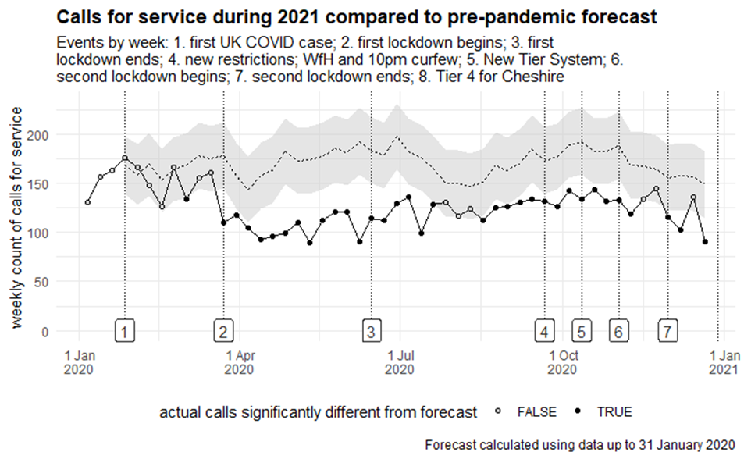

**Figure 13**

## 

## Theme 2: Police response

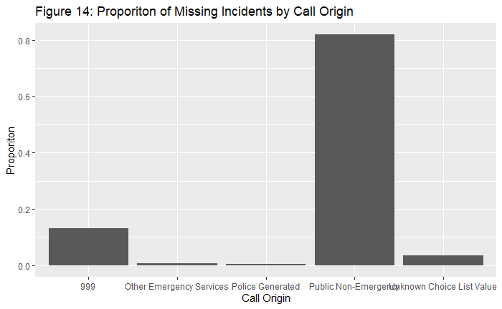Univariate descriptors first highlight some of the basic trends in handling missing incident calls. Figure 14 highlights that the majority of missing incident reports are handled by public non-emergency. This isn’t surprising if most calls are marked as non-urgent, additionally people are advised by Cheshire police to call 101 if not in immediate danger (Cheshire Constabulary, 2021).

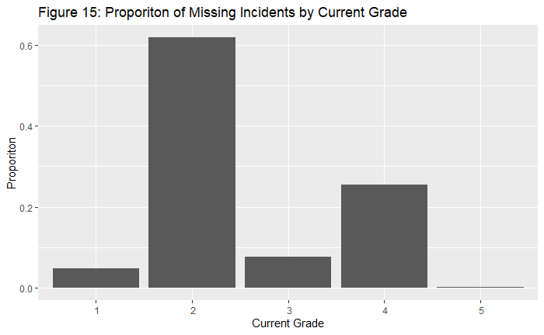The majority of calls are also marked at a Grade 2, at both the initial and the current grading system. At the initial response, there are only 53 grades marked at grade 5 and 1 unspecified grade. Yet at the current grade, those missing incidents at Grade 5 increase to 139. For the purpose of analysis, the focus will be on the Current Grade as this will be used to approximated the ‘harm, opportunity and threat’ principle (GMP, 2017).

The majority of calls are marked as *missing person* at the final classification, given the removal of the absent category from policy this is expected yet we still view how these have changed across grades.

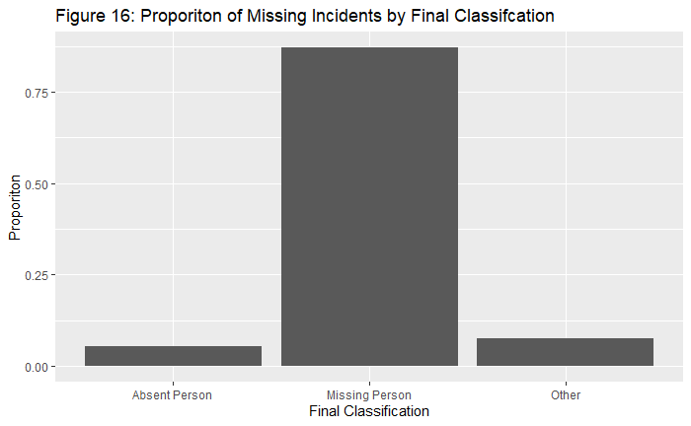

*How are grade responses distrusted across call origin?*

Stacked bar chats were used where the bars for any grade sum to one across all categories of call origin. Figure 17 indicates a large proportion of calls are within the PNE level, with almost 90% of the Grade 3 and 5 calls are within the PNE category. However almost 55% of Grade 1 calls are within the 999 level. This would align with both police information regarding call handling as we expect to see more urgent calls handled by 999.

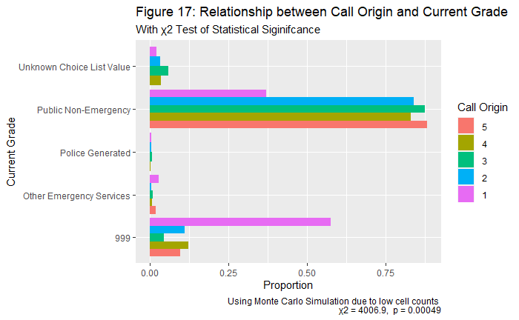

Cranmer’s V is used to measure the strength of the association between an ordinal and nominal variables; the statistic ranges from 0.00 to 1.00 with values closer to 0 indicating weak association (Shishkina et al., 2018). The Cranmer’s V value between call origin and grade is low (0.15) which indicates a relatively week association even though the null hypothesis is rejected on 5%.

*What percentage of calls are recorded as ‘absent, missing or other’ across a) call origin and b) grade?*

Almost 95% of calls classed as absent are within the PNE level whereas roughly 77% of calls classed as missing are within this level. Compared to 999 calls where 17% of calls classed as other, 12% of calls are classed as missing and less than 5% as absent. Despite the null hypothesis being rejected, the Cranmer’s V value is low (0.051), indicating that there is not much of a relationship between these two values. Arguably this is not surprising as the ‘Absent Category’ was discontinued in 2017 hence the use of a time series becomes appropriate.

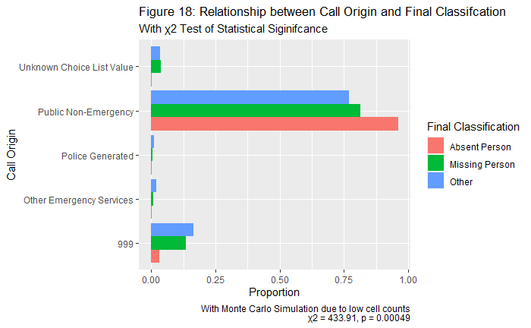

In Figure 19, nearly 80% of the missing category are graded at 2 compared to 50% graded at 5. In the absent category however, nearly 20% are graded at 5 and compared to less than 5% graded at Under the Crame’s V the strength of this association is measured at 0.19, also indicating another week relationship highlighting a weak relationship despite a significance Chi Square. The results from the bivariate analysis have helped to identify what proportion of calls are handled at different response levels, allowing for associations between levels to be examined visually.

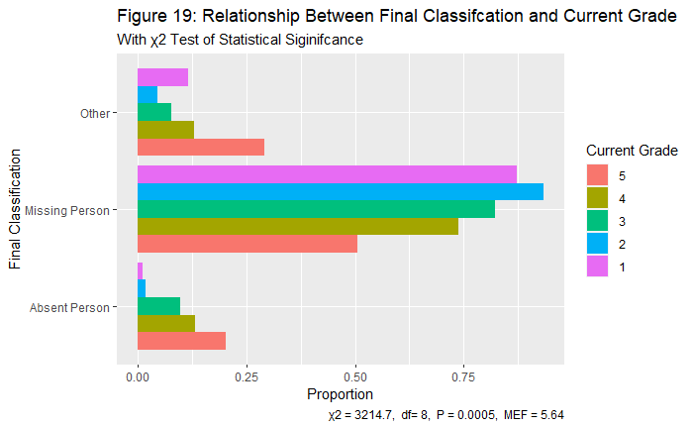

*How has the handling of calls then changed over time?*

Figure 20 supports findings that from 2015 to 2020 roughly 60% to 90% of missing incidents are handled by public non-emergency whereas roughly 10-15% of incidents are handled by 999. This is different to what literature and police state about the handling of missing incidents. Less than 5% of incidents are handled by both Other Emergency Services and Police Generated which is what was expected to see as missing incidents are typically classed as ‘low-level societal crime’. From February 2018 there was an increase in unknown choice list values which were a result of changes to the new call-handling system 5 months prior

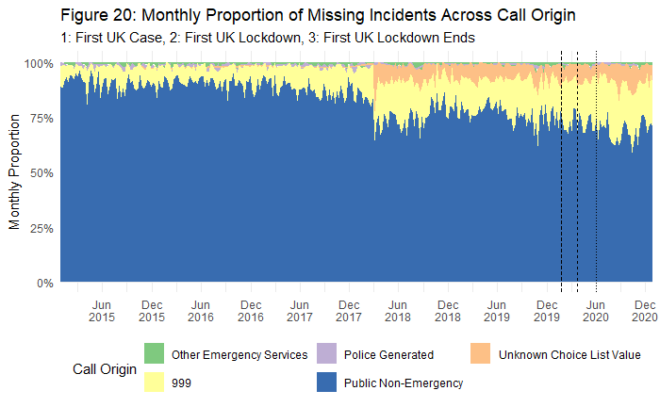

Similarly Figure 21 supports the univariate statistics where most incidents are graded at level 2, followed by level 4, 3 and then 1. The graph also highlights a noticeable change following the first UK case lockdown.

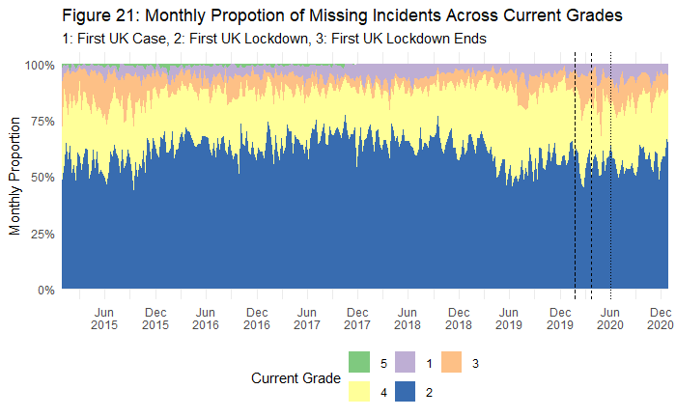

Figure 22 highlights the description of missing incidents at its final classification. The majority of missing incidents are indeed classed as ‘missing, but until March 2018 a portion of these were re-classified as ‘absent person’, following the changes to the call handling system in 2017.

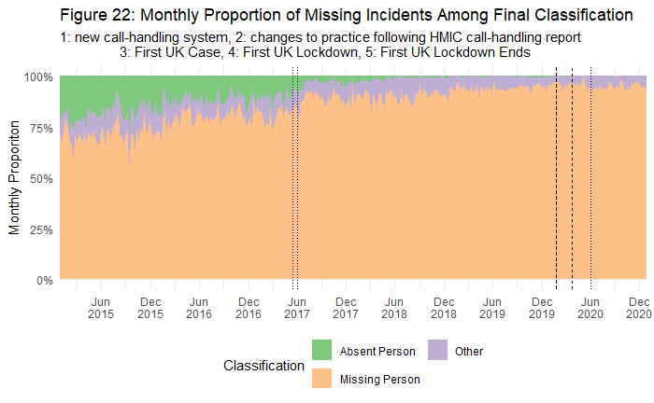

W*hat proportion of calls are attended how are they dependent on a) call origin, b) grade and c) final classifications?*

Out of the 42,019 across 2015-2020, calls 27,355 (65.1%) were attended to. Figure 23 highlights how this has changed over time, showing an increase in attendance rates following the start of the first COVID-19 lockdown.

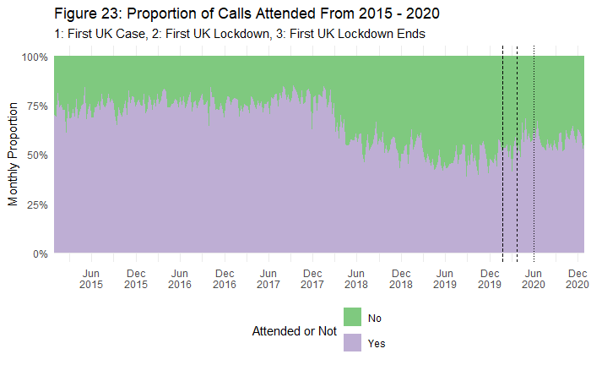

When examining attendance rates amongst call origin, almost 90% of Police generated calls are attended to, compared to roughly 64-69% of public-non emergency and 999 calls attended a missing person call (*Figure 24*). With a Chi Square of 238.86 and 4 degrees of freedom, the probability associated with this value is 1.633532e-50, which is lower than the alpha level of 0.05. All expected counts in the cells are larger than 5, with the smallest value in my outcome of interest (attendance) at 141.270 among the Police Generated category and the strongest value driving the results of the Chi Square among Public Non-Emergency

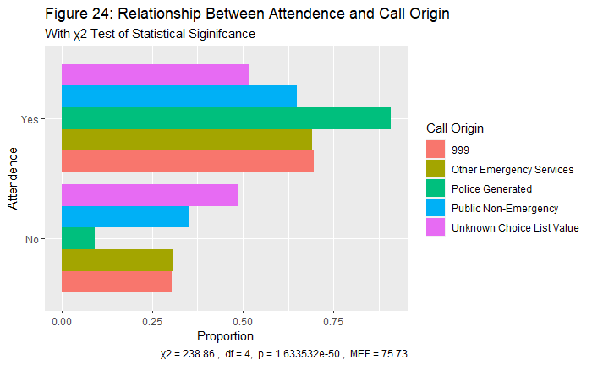

Following the GMP (2017) incident response policy, we expect to see increased attendance in Grade 1. Figure 25 demonstrates that around 97% of calls Grade 1 calls are attended to, compared to 76% of Grade 4 calls that are not attended to. All expected counts in the cells are larger than 5, with the smallest value in my outcome of interest (attendance) being 67 between among the Grade 5 Level. With a Chi Square of 19111.2 and 4 degrees of freedom, the probability associated with this value is 0, which is lower than the alpha level of 0.05. Grade and attendance therefore highlight a relationship in the sample population. The results are also in a position to reject the null hypothesis but to test this strength of relationship we can apply Gamma due to the level of measurements. With a positive value of 0.89, using De Vaus’s guide (2002), we can conclude that a value closer to 1 indicates a stronger association

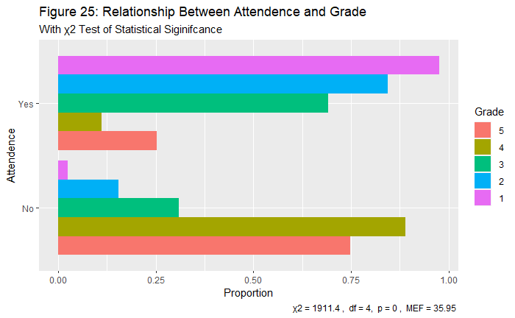

When looking at attendance rates across final classification, 68% of calls classed as ‘missing person’ are attended to compared to 35% of calls classed ‘absent person’ (Figure 26). With a Chi Square of 1310.62 and 2 degrees of freedom, the probability associated with this value is 2.512614e-285, which is lower than the alpha level of 0.05. All expected counts in the cells are larger than 5, with the smallest value in my outcome of interest (attendance) at 1498.37 among the Absence Person Category, and the strongest value which are driving the results of the Chi Square among Missing Persons

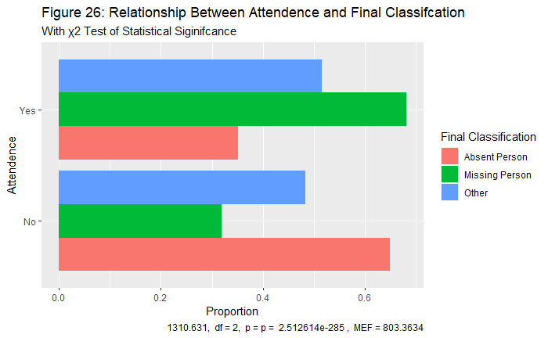

*How does median response time vary across grade?*

The average median response time for services from 2015-2010 to attend a missing person call was measured 32.63 minutes. When specifically examining this response time over the pandemic however, the average response time reduced to 29.63 minutes, with a reduction in calls we would expect to see a reduction in average time.

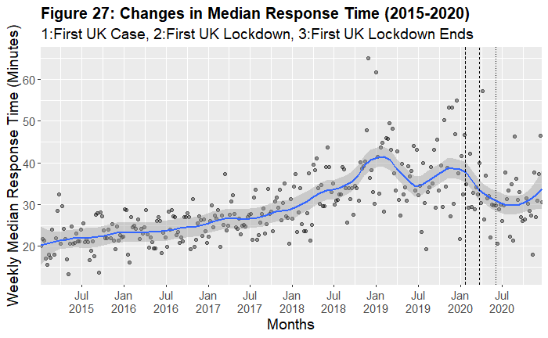

The median response time can also be disaggregated over the grade received. The median response time at each grade was measured at 6.4, 30.6, 40.4, 23.3 and 15.4 (*Figure 28*) which all happen within the expected time frames as indicated under the GMP incident response policy.

**Figure 28:**

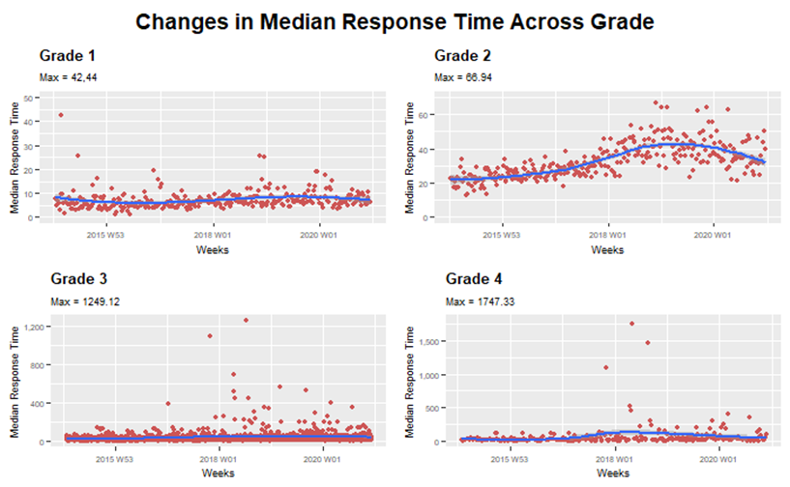

## 

## Theme 3: Environmental and Neighbourhood covariates

### 

The last section of this paper highlights the findings from the spatial regression models that explore the association of missing incident rates in the most deprived areas, and those areas high in mental health cases. Results are shown across both urban and rural LSOAs that conceptualise the density of an area.

### Deprivation:

Literature would summarise that increased crime rates are typically associated with more deprived areas (Beduk and Beduk, 2018; Kawachi et al., 1999), we can test demonstrate this over missing incidents trends by highlighting how many LSOAs from 2015 to 2020 fall within each one of the IMD deciles. Figure 29 highlights that there are higher counts of numbers of missing incidents in more deprived areas, but that these happen amongst a small sample size. For example, 55 LSOAs are marked as most deprived with an average 100 missing incidents, whereas 120 LSOAs are marked as least deprived averaging below 50 missing incidents. This distribution of the IMD is visually presented in Figure 30 where those red areas (most deprived) have the highest counts of missing incidents, they also appear to be clustered amongst other high areas.

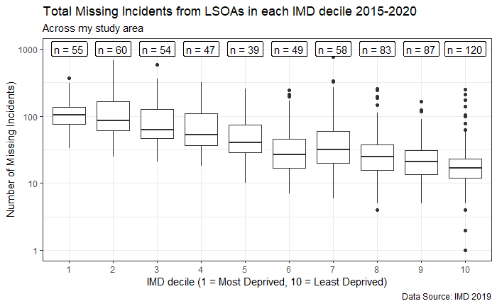

**Figure 29:**

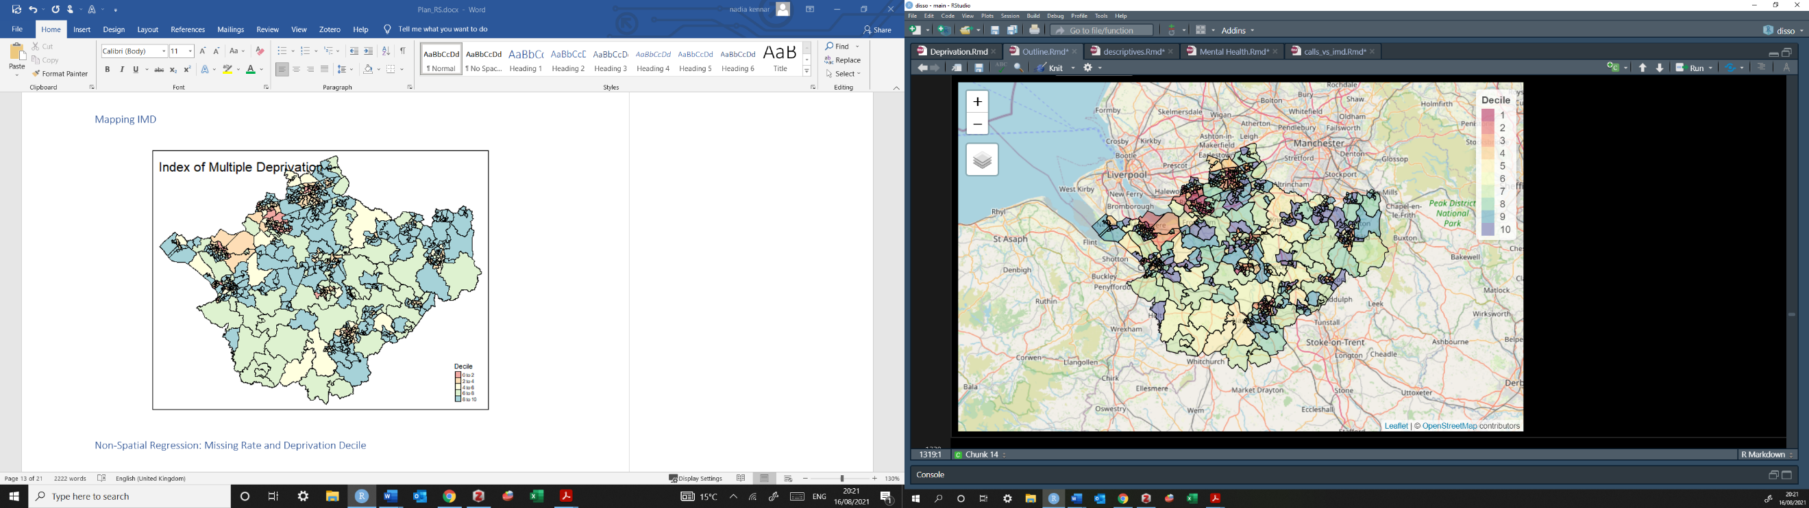***Figure 30: Distribution of IMD Deciles Across LSOAs***

This distribution was explored through the the negative binomial model. The overdispersion was calculated by dividing the residual deviance by the degree of freedom on the poison model where the guide is if this is larger than 1 a negative binomial should be considered (Hilbe, 2011). The estimates slopes are similar but the standard errors were underestimated for the Poisson GLM.

*Table 6: Negative Binomial Model Regression Results for IMD Deciles*

|  |  |  |  |  |  |  |  |
| --- | --- | --- | --- | --- | --- | --- | --- |
|  | Estimate | SE | Z | P | Incident Rate Ratio | 2.5% | 97.5% |
| Intercept | 4.78 | 0.12 | 43.89 | <2e-16 | 118.96 | 96.79 | 148.39 |
| 2 | 0.12 | 0.15 | 0.70 | **0.48** | 1.11 | 0.83 | 1.49 |
| 3 | -0.14 | 0.15 | -0.87 | **0.38** | 0.87 | 0.64 | 1.18 |
| 4 | -0.39 | 0.16 | -2.43 | 0.0015 | 0.67 | 0.49 | 0.93 |
| 5 | -0.63 | 0.17 | -3.72 | 0.000201 | 0.53 | 0.38 | 0.75 |
| 6 | -0.96 | 0.16 | -6.003 | 1/94e-09 | 0.38 | 0.28 | 0.53 |
| 7 | -0.51 | 0.15 | -3.33 | 0.00088 | 0.60 | 0.45 | 0.81 |
| 8 | -1.042 | 0.14 | -7.38 | 1.50e-13 | 0.35 | 0.27 | 0.46 |
| 9 | -1.4 | 0.14 | -9.96 | <2e-16 | 0.25 | 0.19 | 0.33 |
| 10 | -4.48 | 0.13 | -11.21 | <2e-16 | 0.22 | 0.17 | 0.29 |
| Dispersion Parameter = 1.56  Null Deviance: 1032.50, Residual Deviance: 710.08  AIC: 6495.1  Theta: 1.56 Std.Err: 0.082  Log Likelihood: -6473.0990 | | | | | | | |

All coefficients’ estimates are statistically from 0, excluding decile 2 and 3 (in bold). The estimates highlight the expected difference in log count between the levels and the intercept, therefore the expected difference in log count for decile 2 compared to 1 is insignificant. The same applies to the decile 3 compared to 1. The incident rate ratio for decile 4 is 0.67 times the incident rate for decile 1 and the incident rate for decile 5 is 0.53 times the incident rare for decile 1. As the decile gets higher (meaning less deprived areas), incident rate ratios of decile score are expected to have less effect on missing incident scores per LSOA. This excluded decile 7 as an outlier, but nevertheless highlights that the more deprived the area the higher the rate ratio in relation to missing incident. Based on this sample, we are 95% confidence that the true rate ratio at decile 4 lies between 0.49 and 0.93. However, at decile 10 we are 95% confident that the true rate ratio lies between 0.17 and 0.29. The confidence interactions at decile 1 are wider indicating a higher variability but a smaller proportion of calls.

*Spatial Regression*

Figure 31 demonstrates the relationship between missing incidents and deprivation over space. The LISA maps in Theme 1 address autocorrelation as an issue in the overall patterns of missing incidents rates, therefore we can test for autocorrelation considering the relationship between the IMD and missing incident rates.

Figure 31: Choropleth Map of Deprivation Residuals Using Standard Deviation

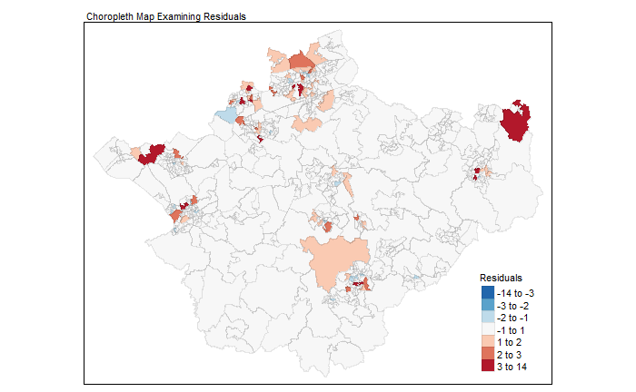

Figure 31 highlights a linear model of missing incident rate and their residuals; negative values indicate that our observed value is lower than the predicted (blue) and positive values indicating that the observed value is higher than the predicted (red). Results conclude that spatial autocorrelation is present in the day and is in fact significant (Moran’s I = 3.4059, P = 0.00066). Therefore, the value would indicate some significant spatial autocorrelation (the errors/residuals are systematically among themselves), where the use of a spatial regression model is thus appropriate.

Spatial regression:

The analysis ran two models accounting for the rural and urban LSOAS. Figure 31 returns a plot with estimated densities of the residuals indicating that rural LSOAs have a higher residual density compared to Urban LSOAs. This indicates that the difference between the observed and the predicted values are smaller for the urban areas than for the rural; the smaller the residual density the closer the values are to 0.

*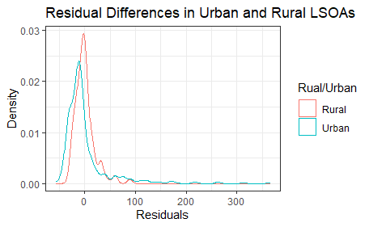Figure 32: Residual Difference in Urban and Rural LSOAs*

The Moran I for residuals on just the rural areas are insignificant (Moran I = 1.23, P = 0.22), therefore we can say that in the rural area we do not have an issue with spatial autocorrelation as the probability value associated with Moran’s I is not above the standard threshold. The Moran I for residuals in the urban areas however, are significant (Moran 1 = 2.67, P = 0.0074). Following the langrage multiplier test, the standard lag and error models were both significant (error = 6.34, p = 0.012: lag = 1247, p = 0.004). Therefore, the robust values were examined (robust error = 3.98, p = 0.046: robust lag = 10.11, p = 0.0012); in this instance the robust multipliers are both significant however as the robust lag is more significant this was used, as guided by Luc Anselm’s (1995). Under the lag model, results indicate that the spatial autoregressive parameter Rho is significant (Rho: 11.944, P: 0.00055). This value is the spatial lag and tells us that when missing incident rates in surrounding urban areas increase, so does the missing incident rate of each LSOA, even when adjusting for deprivation statistics and median age. The lag model has an AIC of 5757.6 whereas the linear model with no lag has an AIC of 5767.5 indicating a model with lag is a more appropriate fit.

As discussed, the least-squares interpretation does not hold in spatial models. Any change to the deprivation decile in a single region (observation) can affect the missing incident rate in all regions (observation). Therefore, as the impact of changes in the deprivation deciles differ over all LSOAs, there are measures set in place to consider the varying impacts (LeSage, 2008). Therefore, using simulated distributions the average direct and indirect impacts were calculated from the regression coefficients (*table 8*).

*Table 8: Average and Direct Effects of IMD Deciles*

|  |  |  |  |  |  |  |
| --- | --- | --- | --- | --- | --- | --- |
| **Column1** | **Direct** | **P** | **Indirect** | **P** | **Total** | **P** |
| IMD2 | 9.2009666 | 2.20E-01 | 2.213786 | 0.271967 | 11.41475 | 2.25E-01 |
| IMD3 | -3.5618564 | 6.89E-01 | -0.856995 | 0.745561 | -4.41885 | 7.00E-01 |
| IMD4 | -21.080563 | 1.73E-02 | -5.072059 | 0.051785 | -26.1526 | 1.84E-02 |
| IMD5 | -13.726908 | 2.50E-01 | -3.302743 | 0.310899 | -17.0297 | 2.55E-01 |
| IMD6 | -25.037795 | 3.70E-02 | -6.024183 | 0.087707 | -31.062 | 4.04E-02 |
| IMD7 | -0.4297561 | 9.87E-01 | -0.103401 | 0.993014 | -0.53316 | 9.88E-01 |
| IMD8 | -28.335987 | 5.44E-04 | -6.81774 | 0.011569 | -35.1537 | 6.29E-04 |
| IMD9 | -36.639295 | 2.69E-04 | -8.815545 | 0.007393 | -45.4548 | 2.84E-04 |
| IMD10 | -34.900524 | 6.93E-05 | -8.397191 | 0.003674 | -43.2977 | 5.71E-05 |
| Age | -1.1219258 | 4.22E-03 | -0.269939 | 0.015481 | -1.39187 | 3.85E-03 |

The average direct impact represents an observation on its own outcome, whereas the average indirect impact is an observation of a neighbour on its outcome. The total impact is simply the total direct and indirect impact of missing incident rates on deprivation deciles. When examining the urban areas, all variables have a significant total effect. Therefore, the total cumulative impact arising from one LSOA with high levels of deprivation of all other LSOAs is significant.

### Mental Health

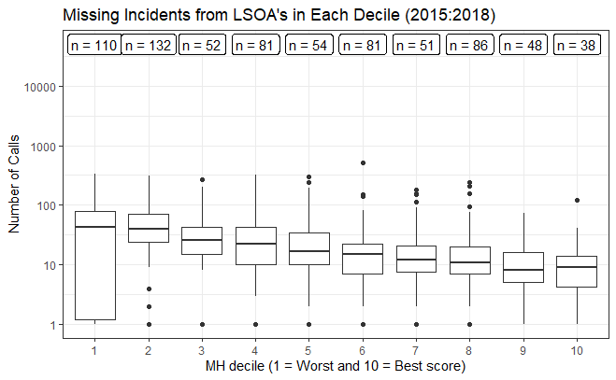Figure 33 demonstrates that there are more LSOAs with worse mental health scores and increased missing incident counts, for example there are 110 LSOAs in decile 1 with an average of 60 missing incident calls whereas there are only 38 LSOAs in decile 10 with an average of 19 missing incidents. There are more missing persons from those LSOAs with increased mental health problems (including NHS-Mental health-related hospital attendances, Prescribing data – Antidepressants, QOF - depression, and DWP - Incapacity benefit and Employment support allowance for mental illness). This distribution is visually presented in Figure 34 where those red areas (highest mental health scores) have the highest counts of missing incidents, as with deprivation scores they also appear to be clustered amongst other high areas.

**Figure 33:**

*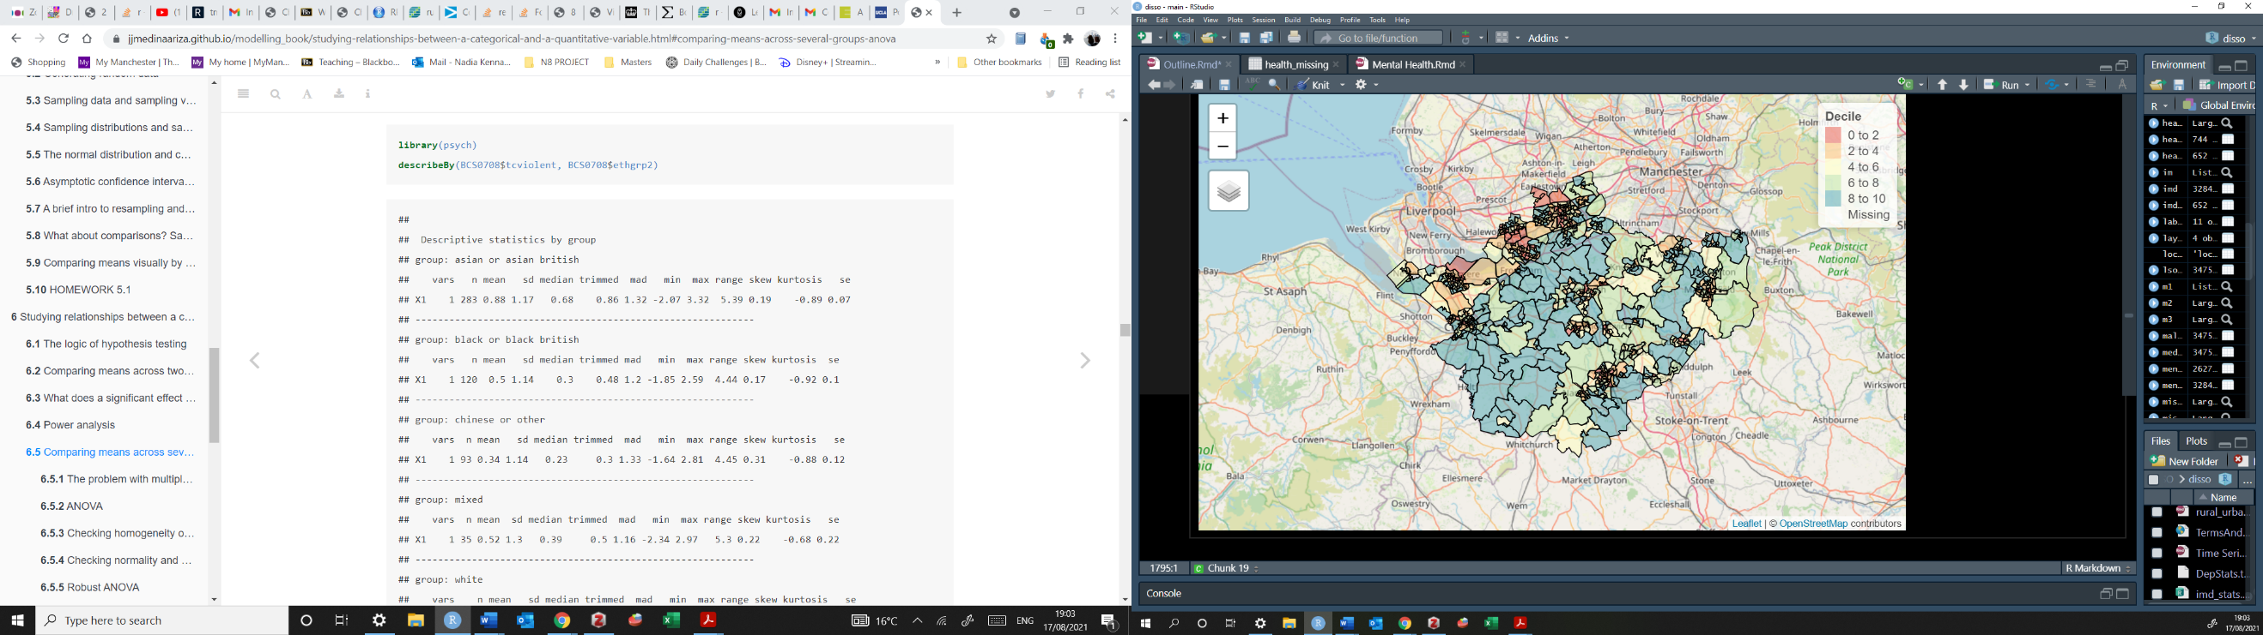Figure 34: Map of Mental Health Deciles Among LSOA*

|  |  |  |  |  |  |  |  |
| --- | --- | --- | --- | --- | --- | --- | --- |
|  | Estimate | SE | Z | P | Incident Rate Ratio | 2.5% | 97.5% |
| Intercept | 4.09 | 0.10 | 39.522 | <2e-16 | 59.99 | 49.28 | 74.006 |
| 2 | -0.09 | 0.14 | -0.67 | **0.49** | 0.91 | 0.69 | 1.19 |
| 3 | -0.44 | 0.18 | -2.44 | 0.014 | 0.64 | 0.45 | 0.92 |
| 4 | -0.42 | 0.16 | -3.24 | 0.0011 | 0.59 | 0.44 | 0.82 |
| 5 | -0.54 | 0.18 | -2.98 | 0.0024 | 0.58 | 0.41 | 0.84 |
| 6 | -0.83 | 0.16 | -5.24 | 1.61e-07 | 0.43 | 0.32 | 0.59 |
| 7 | -0.82 | 0.18 | -4.4 | 1.09e-05 | 0.44 | 0.31 | 0.64 |
| 8 | -1.01 | 0.16 | -6.42 | 1.38e-10 | 0.36 | 0.27 | 0.49 |
| 9 | -1.5 | 0.19 | -7.84 | 4.37e-15 | 0.23 | 0.15 | 0.33 |
| 10 | -1.47 | 0.21 | -7.1 | 1.29e-12 | 0.23 | 0.15 | 0.35 |
| Dispersion Parameter = 0.86  Null Deviance: 982.87 on 743 DF, Residual Deviance: 710.08 on 733 DF  AIC: 6724.1  Theta: 0.86 Std.Err: 0.041  Log Likelihood: -6700.06 | | | | | | | |

Results from the negative binomial regression suggest that all coefficients’ estimates are statistically from 0, excluding decile 2 (in bold); the expected difference in log count for decile 2 compared to 1 is insignificant. The incident rate ratio for decile 3 is 0.64 times higher the incident rate for decile 1 and the incident rate for decile 4 is 0.59 times higher the incident rare for decile 1. As the decile gets higher (meaning better mental health), incident rate ratios of decile score are expected to have less effect on missing incident scores per LSOA. Based on this sample, we are 95% confidence that the true rate ratio lies at decile 4 lies between 0.45 and 0.92. However, at decile 10 we are 95% confident that the true rate ratio lies between 0.15 and 0.53. The confidence interactions at decile 1 are wider indicating a higher variability but a smaller proportion of calls.

Table 10: Negative Binomial Model Regression Results for MH Deciles

*Spatial Regression*

The results from a linear model examining rate and mental health were also examined. The below map highlights both over and underpredictions of our model, indicating that spatial autocorrelation may be present. Each LSOA has an average of 6 neighbours, giving an image about the distribution of connectedness. The Moran’s I statistic (I = 3.2001, p= 0.00014) indicating that spatial autocorrelation is present amongst mental health statistics

*Figure 33: Choropleth Map of Deprivation Residuals Using Standard Deviation 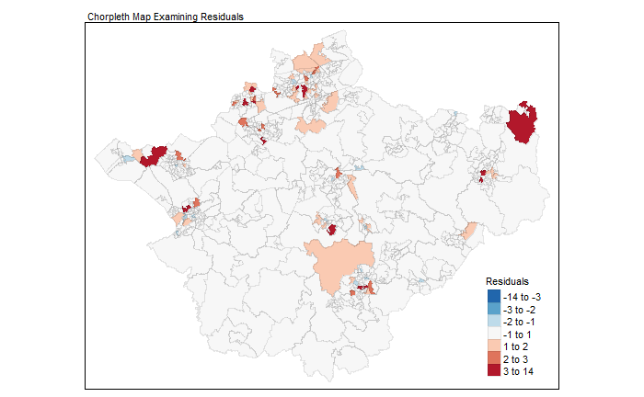*

*Spatial regression*

In the rural LSOAs the Moran statistics are insignificant (I = 0.81 , p = 0.42) again suggesting no issues with spatial autocorrelation. However, in the urban LSOAs the Moran statistic is significant (I = 2.66m p = 0.0077). The probability value associated with the Moran I is below our standard threshold thus indicating a problem with spatial autocorrelation. The LaGrange test was used to decided what spatial model is needed. The diagnostics for spatial dependence, both the standard lag model and the standard error model are significant (error = 6.51, p = 0.012 ; error = 14.012, p = 0.0018). Following the robust multipliers, both the lag and the error model are also significant (robust error = 7.64, p = 0.005: robust lag = 15.345, p = 8.956e-05). As both LM tests reject the null hypothesis, the lag model was chosen as it produces the most significant statistics (Anselin, 1995). Results indicate that the spatial autoregressive parameter Rho is significant (Rho: 0.22, P: 0.00025) therefore, when missing incident rates in surrounding urban areas increase, so does the missing incident rate of each LSOA, even when adjusting for deprivation statistics and median age. The lag model has an AIC of 5733. whereas the linear model with no lag has an AIC of 5784.4, indicating a model with lag is a better fit. We again can interpret the regression coefficients by calculating the direct and indirect effects through simulated distributions.

|  |  |  |  |  |  |  |
| --- | --- | --- | --- | --- | --- | --- |
| **Column1** | **Direct** | **P** | **Indirect** | **P2** | **Total** | **P3** |
| grp2 | -11.6096 | 8.23E-02 | -3.023909 | 0.122247 | -14.6335 | 8.03E-02 |
| grp3 | -28.1373 | 1.95E-03 | -7.328811 | 0.032296 | -35.4661 | 2.49E-03 |
| grp4 | -20.7324 | 4.96E-03 | -5.400098 | 0.052445 | -26.1325 | 6.63E-03 |
| grp5 | -22.4943 | 1.47E-02 | -5.859013 | 0.081816 | -28.3533 | 1.85E-02 |
| grp6 | -30.368 | 4.23E-04 | -7.909848 | 0.014611 | -38.2779 | 3.91E-04 |
| grp7 | -30.012 | 4.89E-04 | -7.817114 | 0.014819 | -37.8291 | 5.06E-04 |
| grp8 | -30.5461 | 2.65E-04 | -7.956237 | 0.011059 | -38.5024 | 2.32E-04 |
| grp9 | -44.1219 | 8.15E-06 | -11.49227 | 0.01628 | -55.6142 | 1.94E-05 |
| grp10 | -41.2239 | 6.19E-05 | -10.73744 | 0.008384 | -51.9613 | 4.79E-05 |
| age | -1.62829 | 1.56E-05 | -0.424113 | 0.006746 | -2.0524 | 1.40E-05 |

Amongst the urban areas, all variables have a significant direct, indirect and total effect concluding that. The total cumulative impact arising from one LSOA with high mental health scores of all other LSOAs is significant.

# Discussion

Interpret:

This paper has combined information from many independent sources in order to produce descriptive and statistical plots to better understand missing person incidents. In the first instance this paper examined the spatial and the temporal trends through LISA maps and time series decompositions. Significant Local Moran’s I statistics on the missing incident rate (per 1000 residential population) highlighted a positive spatial autocorrelation where high levels of missing incidents are associated with other high areas of missing incidents. This gave an insight into the spatial dependence where the distribution of high values is more spatially clustered than if the underlying spatial process were random. We can conclude that there are spatial patterns of missing incidents across the study area. The use of seasonal variation and the X11 decomposition methods also exposed the trend, seasonality and noise components of the data. Typically, we have an increasing quadratic trend of missing incidents from 2015 to 2019, following a decline in 2020 as a result of the pandemic changing the daily routines of both society and police responses. The seasonally adjusted data modifies the effect of seasonal influences which provide for more meaningful comparisons; we can conclude that missing incident reports most frequently happen over the summer months and less frequently over the winter month. The SARIMA models were useful in explaining the trends seen in 2020, where the observed counts were much lower than the forecast data supporting research on changes to routine activities.

Theme 2 explored the police response to missing persons providing both descriptive and temporal trends. Despite literature stating most calls are handled by 999, the results from this paper show that PNE handle the majority of calls, additionally most of the calls are graded at level 2. The results of the temporal trends highlighted a consistency in the allocation of police response with the main call origin and grade rarely changing. However, the median response time highlighted an increasing trend which may be a result of new policy introduced in 2018. It’s also interesting to note how the incident policy response time from GMP (2019) did not match the average response time for each grade but instead were much quicker at resource allocation. Additionally, the classification of ‘absent person’ was reduced from 2017 as this was removed from policy.

Theme 3 explores the neighbourhood covariates where missing incidents are more prone in higher deprived LSOAs and higher mental health scores LSOAs. Additionally, the spatial regressions highlighted that missing incident rates are clustered among urban LSOAS, whereas rural provide insignificant Moran statistics. Missing incidents make up 2.4% of calls from the whole calls for service dataset, yet results highlight that these are spatially clustered in 18.8% of our study space (the 103 urban LSOAs) of which are also high in deprivation statistics and mental health concerns. Summarising the results, each theme has allowed for a platform enabling the intersection between spatial trends, temporal analysis and descriptive police response that have emerged to tell the story of missing incidents.

Implications:

Quantitative trends in missing incidents are extremely rare due to the complexity of *going missing,* the results from the study have helped to shed light on some temporal and spatial patterns that contribute to the discursive platform while providing a new perspective to the study of missing incidents. It is necessary to understand these trends so we can then break down the complexity of *going missing.* From a theoretical perspective the routine activity theory can successfully be used to justify the results in theme 1, in that changes in season fluctuates the level of missing incidents but also how the pandemic has decreased levels of missing incidents. However, without additional contextual details such as gender or whether it was an child or adult report, no further conclusions can be drawn. Crime rates are lower in rural areas compared to urban areas (Piroozfar et al., 2019; Wells and Weisheit, 2004) yet this theory has never been applied to the distribution of missing incident rates. Therefore, this study adds to the literature by accounting for one type of non-crime trend and its placement in urban or rural areas. Additionally, increased deprivation and increased mental health (Dustmann and Fasani, 2011) have been found in urban areas so to draw on an association here was necessary in painting a picture of how missing incidents are affected by environmental correlates. From a policing perspective I suggest that the results reported in the study provide a descriptive analysis of environmental correlates associated with missing persons, as well as an analysis on how different services responds to incidents, that can be used to help justify resource allocation across those most *vulnerable* areas.

Recommendations:

Following the premise of this paper, future quantitative research into missing incidents could expand in two ways. Firstly, by expanding the study space and comparing trends across different police forces in order to obtain a more generalisable conclusion. Police forces in the U.K have varying methods to responding to missing incidents, some use a risk-based system and others a more discrete grading system, affecting the intersectionality of comparable results. Although there may be complications in comparing different systems due to differences in definitions of ‘missing’, I believe by increasing intersectionality between agency and policy response a more unified definition could be created. Secondly, by extending research and examining the association between police response across environmental factors. For example, whether there is a difference between median response time in different deprivation LSOAs and mental health LSOAs, or how police responses differ across urban/rual LSOAs. By examining if there is spatial association between police responses to missing incidents and differing environmental covariates, we could introduce a micro-level geospatial crime prevention strategy that attempts to understand and improve how police responses might possibly affect the outcome of case, but more importantly to identify areas in the response policy that need improvement. This is important in the study of missing incidents because now we know *where* missing incidents occur, but knowing *when* is the challenge due to the complicated individualistic characteristics that make each case so different. Therefore, by providing information on where police responses differ and how these have affected the outcome of a case, we might be able to extend the discursive platform.

# Conclusion

(aims) In this study we have assessed the spatial/temporal variation of missing incidents in Cheshire, from 2015 to 2020, using various statistical methods. Although the finding adds to the literature and compliments the discursive platform, this study is not without limitations as previously discussed therefore it is necessary to readdress the complications surrounding the conceptualisation of ‘missing’. Quantitative analysis on victimisation studies tend to limit the individual experience due to studying and grouping results that apply to only a snapshot of the population. The reasons for why people go missing is still not entirely understood so the use of aggregated data tends to minimise these experiences. Nevertheless, this research contributes to one of few quantitative studies on missing persons that builds on a body of research that has applied temporal and spatial techniques to investigate trends and geographical patterns of missing incidents. The use of these methods advances the theoretical backgrounds as well as the political. While there have been advancements in the use of spatial analysis and the range to which these are available in GIS packages, it should be noted that some of the methods used in this paper are not routinely available to both criminologists but also both police and missing person agencies. This paper hopes to highlight the advantages of incorporating new techniques to any crimes or criminal activity, specifically those classed as ‘non-crime’ that have been heavily adopted by qualitative researchers, in the field of temporal and spatial geospatial analysis. The use of CFS also provides a broader implementation to policy making, typically in criminology a top-down approach is applied starting from the perspective of governmental agencies. However, this typically neglects other actors. The use of CFS incorporates the use of multiple services and not just police-recorded instances thus allowing for responses to missing incidents to be studied from a wider perspective

Returning specifically to my research questions, we have found that missing incidents do hold spatial patterns that cluster among specific hotspots while also highlighting significant seasonal variation. Moreover, I have been able to highlight how changes to people’s routine activities as result of Covid-19 have different temporal and seasonal patterns compared to previous years. With regard to the police responses, we have provided one of the first analysis on missing incidents using CFS in order to provide descriptive statistics on the changing patterns of police and agency responses. Lastly, the use of geospatial technique has highlighted a statistical association between area-level deprivation among urban LSOAS and missing incidents. And a statistical association between missing incidents and mental health at the neighbourhood level. Conclusively, each research question among the three themes have been met through the use of robust temporal and spatial methods where understanding these trends will help clarify the often complex and unclear information surrounding research in missing persons.

-

# References

Allen, M., 2017. Simple Bivariate Correlation - SAGE Research Methods.

Andresen, M.A., Malleson, N., 2011. Testing the Stability of Crime Patterns: Implications for Theory and Policy. Journal of Research in Crime and Delinquency 48, 58–82. https://doi.org/10.1177/0022427810384136

Anselin, L., 1995. Local Indicators of Spatial Association—LISA. Geographical Analysis 27, 93–115. https://doi.org/10.1111/j.1538-4632.1995.tb00338.x

Ashby, M.P.J., Tompson, L., 2017. Routine Activities and Proactive Police Activity: A Macro-scale Analysis of Police Searches in London and New York City. Justice Quarterly 34, 109–135. https://doi.org/10.1080/07418825.2015.1103380

Beduk, S., Beduk, S., 2018. Missing the Unhealthy? Examining Empirical Validity of Material Deprivation Indices (MDIs) Using a Partial Criterion Variable. Social indicators research 135, 91–115. https://doi.org/10.1007/s11205-016-1483-2

Biehal, N., Mitchell, F., Wade, J., 2003a. Lost from view: missing persons in the UK. The Policy Press, Bristol, UK.

Biehal, N., Mitchell, F., Wade, J., 2003b. Lost from view Missing persons in the UK.

Biehal, N., Wade, J., 2000. Going missing from residential and foster care: Linking biographies and contexts. British Journal of Social Work 30. https://doi.org/10.1093/bjsw/30.2.211

Boulton, L., McManus, M., Metcalfe, L., Brian, D., Dawson, I., 2017. Calls for police service: Understanding the demand profile and the UK police response. The Police Journal 90, 70–85. https://doi.org/10.1177/0032258X16671032

Brewin, C., DePierro, P., 2020. Why we need to integrate mental health into pandemic planning - CR Brewin, J DePierro, P Pirard, C Vazquez, R Williams, 2020.

Buil-Gil, D., Medina, J., Shlomo, N., 2021. Measuring the dark figure of crime in geographic areas: Small area estimation from the Crime Survey for England and Wales. The British Journal of Criminology 61, 364–388. https://doi.org/10.1093/bjc/azaa067

Castro, M.C. de, Singer, B.H., 2006. Controlling the False Discovery Rate: A New Application to Account for Multiple and Dependent Tests in Local Statistics of Spatial Association. Geographical Analysis 38, 180–208. https://doi.org/10.1111/j.0016-7363.2006.00682.x

Cheshire Constabulary, 2021. Cheshire Constabulary - Missing Persons, Adivce and Information [WWW Document]. URL https://www.cheshire.police.uk/advice/advice-and-information/missing-person/missing-persons/find-someone-you-have-lost-touch-with/ (accessed 9.15.21).

Coleman, J., 1990. Foundations of Social Theory — James Coleman [WWW Document]. URL https://www.hup.harvard.edu/catalog.php?isbn=9780674312265 (accessed 8.24.21).

College of Policing, 2015. Demand Analysis Report | College of Policing [WWW Document]. URL https://www.college.police.uk/About/Pages/Demand-Analysis-Report.aspx (accessed 1.12.21).

Cryer, J.D., Chan, K.-S. (Eds.), 2008. Forecasting, in: Time Series Analysis: With Applications in R, Springer Texts in Statistics. Springer, New York, NY, pp. 191–226. https://doi.org/10.1007/978-0-387-75959-3_9

de Melo, S.N., Pereira, D.V.S., Andresen, M.A., Matias, L.F., 2018. Spatial/Temporal Variations of Crime: A Routine Activity Theory Perspective. Int J Offender Ther Comp Criminol 62, 1967–1991. https://doi.org/10.1177/0306624X17703654

De Vaus, D.A., 2002. Surveys in Social Research, Social Research Today. Taylor & Francis [CAM], London.

Deas, I., Robson, B., Wong, C., Bradford, M., 2003. Measuring Neighbourhood Deprivation: A Critique of the Index of Multiple Deprivation. Environ Plann C Gov Policy 21, 883–903. https://doi.org/10.1068/c0240

Donoghue, J., 2013. Reflections on Risk, Anti-Social Behaviour and Vulnerable/Repeat Victims. British Journal of Criminology 53, 805–823. https://doi.org/10.1093/bjc/azt023

Douglas, M., Ney, S., 1998. Missing Persons: A Critique of the Personhood in the Social Sciences. University of California Press.

Dustmann, C., Fasani, F., 2011. DIGITAL.CSIC: Crime and mental health in the UK.

Edkins, J., 2011. Missing: Persons and Politics. Cornell University Press.

Farrington, D.P., Loeber, R., Ttofi, M.M., 2012. Risk and Protective Factors for Offending [WWW Document]. The Oxford Handbook of Crime Prevention. https://doi.org/10.1093/oxfordhb/9780195398823.013.0003

Felson, M., Jiang, S., Xu, Y., 2020. Routine activity effects of the Covid-19 pandemic on burglary in Detroit, March, 2020. Crime Science 9, 10. https://doi.org/10.1186/s40163-020-00120-x

Flyvbjerg, B., 2006. Five Misunderstandings About Case-Study Research. Qualitative Inquiry 12, 219–245. https://doi.org/10.1177/1077800405284363

Fyfe, N., Parr, H., Stevenson, O., Woolnough, P., 2015. ‘To the End of the World’: Space, Place, and Missing Persons Investigations. Policing 9, 275–283. https://doi.org/10.1093/police/pav025

Fyfe, N.R., 1991. The police, space and society : the geography of policing. Progress in Human Geography 15, 249–267. https://doi.org/10.1177/030913259101500301

Gibb, G., Woolnough, P., 2007. Missing persons: Understanding, planning, responding. Aberdeen: Grampian Police.

GMP, G.M.P., 2017. Incident Response Policy.

Graber, H., Stern, J., 2018. In America, calling 911 is still a privilege of being white. [WWW Document]. URL https://slate.com/news-and-politics/2018/05/in-america-calling-911-is-still-a-privilege-of-being-white.html (accessed 8.27.21).

Greater Manchester Police, 2017. Incident Response Policy, Greater Manchester Police.

Guardianship (Missing Persons) Act 2017, 2017. Guardianship (Missing Persons) Act 2017. Queen’s Printer of Acts of Parliament.

Heap, V., 2016. Putting victims first? A critique of Coalition anti-social behaviour policy. Critical Social Policy 36, 246–264. https://doi.org/10.1177/0261018315624173

Heller-Roazen, D., 2021. Absentees: On Variously Missing Persons. Zone Books. https://doi.org/10.2307/j.ctv161f3h9

Henderson, M., Henderson, P., Kiernan, C., 2000. Missing Persons: Incidence, Issues and Impacts. Australian Institute of Criminology: Trends and Issues in Crime and Criminal Justice 144.

Hickman, M.J., Atherley, L.T., Alpert, G.P., 2014. Using GIS to Monitor and Investigate Police Use of Force: The Spatial Distribution of Force Factors, in: Elmes, G.A., Roedl, G., Conley, J. (Eds.), Forensic GIS: The Role of Geospatial Technologies for Investigating Crime and Providing Evidence, Geotechnologies and the Environment. Springer Netherlands, Dordrecht, pp. 173–199. https://doi.org/10.1007/978-94-017-8757-4_9

Hilbe, J.M., 2011. Negative Binomial Regression. Cambridge University Press.

Hirschel, J.D., Lab, S.P., 1988. Who is missing? The realities of the missing persons problem. Journal of Criminal Justice 16, 35–45. https://doi.org/10.1016/0047-2352(88)90034-7

Hyndman, R.J., Athanasopoulos, G., 2018. Forecasting: principles and practice. OTexts.

Jebb, A.T., Parrigon, S., Woo, S.E., 2017. Exploratory data analysis as a foundation of inductive research. Human Resource Management Review 27, 265–276. https://doi.org/10.1016/j.hrmr.2016.08.003

Kawachi, I., Kennedy, B.P., Wilkinson, R.G., 1999. Crime: social disorganization and relative deprivation. Social Science & Medicine 48, 719–731. https://doi.org/10.1016/S0277-9536(98)00400-6

Kennedy, B.P., Kawachi, I., Prothrow-Stith, D., Lochner, K., Gupta, V., 1998. Social capital, income inequality, and firearm violent crime. Soc Sci Med 47, 7–17. https://doi.org/10.1016/s0277-9536(98)00097-5

Langton, S., Farrell, G., Dixon, A., 2020. Six Months In: Pandemic Crime Trends in England and Wales. SocArXiv. https://doi.org/10.31235/osf.io/t7ne8

LeSage, J.P., 2008. An Introduction to Spatial Econometrics. Revue d’économie industrielle 19–44. https://doi.org/10.4000/rei.3887

Little, R.J.A., Rubin, D.B., 2002. Single Imputation Methods, in: Statistical Analysis with Missing Data. John Wiley & Sons, Ltd, pp. 59–74. https://doi.org/10.1002/9781119013563.ch4

Maglione, G., 2017. Embodied victims: An archaeology of the ‘ideal victim’ of restorative justice. Criminology & Criminal Justice 17, 401–417. https://doi.org/10.1177/1748895816677172

Makin, D.A., Meize, M.R., Willits, D.W., Stohr, M.K., Hemmens, C., Lovrich, N.P., Nordman, A., Stanton, D., 2021. The impact of recreational marijuana sales on calls for service: an analysis of neighbouring cities. Policing and Society 31, 848–862. https://doi.org/10.1080/10439463.2020.1773461

Malleson, N., Andresen, M.A., 2016. Exploring the impact of ambient population measures on London crime hotspots. Journal of Criminal Justice 46, 52–63. https://doi.org/10.1016/j.jcrimjus.2016.03.002

Merton, R.K., Merton, R.C., 1968. Social Theory and Social Structure. Simon and Schuster.

Missing People Ltd, 2021. Missing People Organisaiton [WWW Document]. Missing People. URL https://www.missingpeople.org.uk/ (accessed 8.29.21).

Morewitz, S.J., 2016. Handbook of Missing Persons. Springer International Publishing AG, Springer International Publishing, Springer, Cham. https://doi.org/10.1007/978-3-319-40199-7

Newiss, G., 2005. A Study of the Characteristics of Outstanding Missing Persons: Implications for the Development of Police Risk Assessment. Policing and Society 15, 212–225. https://doi.org/10.1080/10439460500071655

Newiss, G., 1999. Missing Presumed ...?: The Police Response to Missing Persons. Home Office, Policing and Reducing Crime Unit, Research, Development and Statistics Directorate.

Pabesma, E., 2018. Simple Features for R: Standardized Support for Spatial Vector Data. The R Journal 10 (1), 439-446,.

Parr, H., Fyfe, N., 2013. Missing geographies. Progress in Human Geography 37, 615–638. https://doi.org/10.1177/0309132512465919

Piroozfar, P., Farr, E.R.P., Aboagye-Nimo, E., Osei-Berchie, J., 2019. Crime prevention in urban spaces through environmental design: A critical UK perspective. Cities 95, 102411. https://doi.org/10.1016/j.cities.2019.102411

R Core Team, 2021. A language and environment for statistical computing. R Foundation for Statistical Computing, Vienna, Austria.

Reis, S., Liška, T., Vieno, M., Carnell, E.J., Beck, R., Clemens, T., Dragosits, U., Tomlinson, S.J., Leaver, D., Heal, M.R., 2018. The influence of residential and workday population mobility on exposure to air pollution in the UK. Environment International 121, 803–813. https://doi.org/10.1016/j.envint.2018.10.005

Sampson, R.J., 1995. Sampson, R.J. (1995) The Community, 193-216. In: Wilson, J.Q. and Petersilia, J., Eds., Crime, ICS Press, San Francisco.

Shalev Greene, K., O’Brien, F., Collie, C.J.R., Giles, S., 2020. The Impact of COVID-19 Lockdown Restrictions on Missing Person Reports. University of Portsmouth.

Shalev Greene, K., Pakes, F., 2013. The Cost of Missing Person Investigations: Implications for Current Debates. Policing 8, 27–34. https://doi.org/10.1093/police/pat036

Shalev Greene, K., Schaefer, M., Morgan, A., 2009. Investigating Missing Person Cases: How Can We Learn Where They Go or How Far They Travel? International Journal of Police Science and Management 11, 123–129. https://doi.org/10.1350/ijps.2009.11.2.116

Shaw, C.R., McKay, H.D., 1942. Juvenile delinquency and urban areas, Juvenile delinquency and urban areas. University of Chicago Press, Chicago, IL, US.

Shishkina, T., Farmus, L., Cribbie, R., 2018. Testing for a Lack of Relationship Among Categorical Variables.

Solymosi, R., Medina, J., 2021. Chapter 9 Spatial regression models | Crime Mapping in R.

Sowerby, A., Thomas, S.D.M., 2017. A mixed methods study of the mental health and criminal justice histories of missing persons. Police Practice and Research 18, 87–98. https://doi.org/10.1080/15614263.2016.1230062

Squires, P., 2006. New Labour and the politics of antisocial behaviour. Critical Social Policy 26, 144–168. https://doi.org/10.1177/0261018306059769

Srinivasan, S., 2008. Spatial Regression Models, in: Shekhar, S., Xiong, H. (Eds.), Encyclopedia of GIS. Springer US, Boston, MA, pp. 1102–1105. https://doi.org/10.1007/978-0-387-35973-1_1294

Stevenson, E., Thomas, S.D.M., 2018. A 10 year follow-up study of young people reported missing to the police for the first time in 2005. Journal of Youth Studies 21, 1361–1375. https://doi.org/10.1080/13676261.2018.1468874

Stevenson, O., Parr, H., Woolnough, P., 2017. Missing women: policing absence. Transactions of the Institute of British Geographers 42, 220–232. https://doi.org/10.1111/tran.12160

Stevenson, O., Woolnough, P., 2013. Geographies of missing people: processes, experiences and responses. https://doi.org/10.5255/UKDA-SN-851480

Tarling, R., Burrows, J., 2004. The Nature and Outcome of Going Missing: The Challenge of Developing Effective Risk Assessment Procedures. International Journal of Police Science & Management 6, 16–26. https://doi.org/10.1350/ijps.6.1.16.34459

Taylor, R.B., Wyant, B.R., Lockwood, B., 2015. Variable links within perceived police legitimacy?: Fairness and effectiveness across races and places. Social Science Research 49, 234–248. https://doi.org/10.1016/j.ssresearch.2014.08.004

Tennekes, M., 2018. Thematic Maps in R.” _Journal of Statistical Software_, *84*(6), 1-39. doi: 10.18637/jss.v084.i06.

Thorsen, C., Henry, A., Cliffordson, C., 2020. The case of a missing person? The current L2 self and the L2 Motivational Self System. International journal of bilingual education and bilingualism 23, 584–600. https://doi.org/10.1080/13670050.2017.1388356

Treiman, D.J., 2009. Quantitative Data Analysis: Doing Social Research to Test Ideas. John Wiley & Sons, Incorporated, New York, NY, UNITED STATES.

UK Missing Persons, 2021. UK Missing Persons Unit [WWW Document]. MPB. URL http://missingpersons.police.uk/en-gb/resources/downloads/missing-persons-statistical-bulletins (accessed 8.29.21).

UKMPU, 2016. National Crime Agency - National Crime Agency.

van Sleeuwen, S.E.M., Ruiter, S., Steenbeek, W., 2021. Right place, right time? Making crime pattern theory time-specific. Crime Science 10, 2. https://doi.org/10.1186/s40163-021-00139-8

Vilalta, C., Fondevila, G., 2021. Testing Routine Activity Theory in Mexico. The British Journal of Criminology 61, 754–772. https://doi.org/10.1093/bjc/azaa089

Warner, B.D., Pierce, G.L., 1993. Reexamining Social Disorganization Theory Using Calls to the Police as a Measure of Crime*. Criminology 31, 493–517. https://doi.org/10.1111/j.1745-9125.1993.tb01139.x

Weisburd, D., 2015. The Law of Crime Concentration and the Criminology of Place*. Criminology 53, 133–157. https://doi.org/10.1111/1745-9125.12070

Wells, L.E., Weisheit, R.A., 2004. Patterns of Rural and Urban Crime: A County-Level Comparison. Criminal Justice Review 29, 1–22. https://doi.org/10.1177/073401680402900103

Weston, S.J., Ritchie, S.J., Rohrer, J.M., Przybylski, A.K., 2019. Recommendations for Increasing the Transparency of Analysis of Preexisting Data Sets. Advances in Methods and Practices in Psychological Science 2, 214–227. https://doi.org/10.1177/2515245919848684

Wickham, H., 2016. Elegant Graphics for Data Analysis. Springer-Verlag New York.

Wilson, J.M., 2012. Articulating the dynamic police staffing challenge: An examination of supply and demand. Policing: An International Journal of Police Strategies & Management 35, 327–355. https://doi.org/10.1108/13639511211230084

Wong, D.W.S., 2004. The Modifiable Areal Unit Problem (MAUP), in: Janelle, D.G., Warf, B., Hansen, K. (Eds.), WorldMinds: Geographical Perspectives on 100 Problems: Commemorating the 100th Anniversary of the Association of American Geographers 1904–2004. Springer Netherlands, Dordrecht, pp. 571–575. https://doi.org/10.1007/978-1-4020-2352-1_93

Wortley, R., Townsley, M., 2016. Environmental Criminology and Crime Analysis. Routledge.

# Appendix:

## Appendix A - Urban/Rural Classification

Table 1 – Rural and Urban Classification (2011) in Cheshire

|  |  |
| --- | --- |
| Classification | Count |
| Rural Town and Fringe | 56 |
| Rural town and fringe in a sparse setting | *NA* |
| Rural village and dispersed | 47 |
| Rural village and dispersed in a sparse setting | NA |
| Total Rural = 103 | |
| Urban city and town | 520 |
| Urban city and town in a sparse setting | *NA* |
| Urban major conurbation | 29 |
| Urban minor conurbation | NA |
|  |  |
| Total Rural = 549 | |
| *N = 652* | |

## Appendix B – Areas outside of our LA

Figure 1

…

## Appendix C – Call Origin

Table 2 – Call Origin Original Levels

|  |  |
| --- | --- |
| Call Origin | Count |
| 1) Public Non-Emergency 34585 | 43685 |
| * *Public Non-Emergency* | *34376* |
| * *Single Online Home* | *3* |
| * *Social Media* | *3* |
| * *Alarm Company* | *5* |
| * *ANPR* | *3* |
| * *Helpdesk* | *195* |
| * *Email* | *143* |
| 2) 999 | 5667 |
| 3) Other Emergency service | 364 |
| 4) Police Generated | 228 |
| 5) Unknown | 15600 |
| *N = 42019* | |

## Appendix D – Final Classification

Table 3 – Final Classification Level

|  |  |
| --- | --- |
| Call Origin | Count |
| 1. Missing | 36004 |
| 1. Absent | 2302 |
| 1. Other | 3113 |
| *Abandoned phone call* | 4 |
| *Absconder* | 3 |
| *Advice/direction/alarm* | 199 |
| *ASB* | 7 |
| *Bail Breaches* | 63 |
| *Burglary* | 5 |
| *Civil Disputes* | 4 |
| *Concern for safety* | 1713 |
| *Crime not Verified* | 31 |
| *Crime related incidents* | 4 |
| *Criminal damage* | 31 |
| *Damage only RTC* | 1 |
| *Domestic Incident (Adult)* | 71 |
| *Domestic Incident (Child)* | 13 |
| *Drugs* | 7 |
| *Environmental ASB* | 2 |
| *Fraud* | 1 |
| *Hoax call* | 2 |
| *Industrial accident* | 1 |
| *Intelligence information* | 4 |
| *Kidnap* | 2 |
| *Message to Pass* | 185 |
| *Nuisance ASB* | 3 |
| *Other Notifiable Crime* | 6 |
| *Personal ASB* | 3 |
| *PNC Markers* | 7 |
| *Police Generated* | 74 |
| *Pre-planned Events* | 2 |
| *Road Related Traffic Offence* | 1 |
| *Robbery* | 2 |
| *Sexual Offence* | 27 |
| *Simple Advice* | 139 |
| *Sudden dearth* | 32 |
| *Suspicious activity* | 6 |
| *Task incident* | 23 |
| *Theft (other/shoplifting/motor vehicle)* | 35 |
| *Training* | 1 |
| *Truancy* | 251 |
| *Violence* | 154 |
| *N = 42019* | |
|  | |
|  | |

Appendix E – Packages

1. Baptiste Auguie (2017). gridExtra: Miscellaneous Functions for "Grid" Graphics. R package version 2.3. <https://CRAN.R-project.org/package=gridExtra>
2. Bivand, Roger S. and Wong, David W. S. (2018) Comparing implementations of global and local indicators of spatial association TEST, 27(3), 716-748. URL: <https://doi.org/10.1007/s11749-018-0599-x>
3. Carslaw, D. C. and K. Ropkins, (2012) openair --- an R package for air quality data analysis. Environmental Modelling & Software. Volume 27-28, 52-61.
4. Claus O. Wilke (2020). cowplot: Streamlined Plot Theme and Plot Annotations for 'ggplot2'. R package version 1.1.1. <https://CRAN.R-project.org/package=cowplot>
5. D. Kahle and H. Wickham. ggmap: Spatial Visualization with ggplot2. The R Journal, 5(1), 144-161. URL http://journal.r-project.org/archive/2013-1/kahle-wickham.pdf
6. Dewey Dunnington (2021). ggspatial: Spatial Data Framework for ggplot2. R package version 1.1.5. <https://CRAN.R-project.org/package=ggspatial>
7. Garrett Grolemund, Hadley Wickham (2011). Dates and Times Made Easy with lubridate. Journal of Statistical Software, 40(3), 1-25. URL <https://www.jstatsoft.org/v40/i03/>.
8. Gregory R. Warnes, Ben Bolker, Lodewijk Bonebakker, Robert Gentleman, Wolfgang Huber, Andy Liaw, Thomas Lumley, Martin Maechler, Arni Magnusson, Steffen Moeller, Marc Schwartz and Bill Venables (2020). gplots: Various R Programming Tools for Plotting Data. R package version 3.1.1. <https://CRAN.R-project.org/package=gplots>
9. Hadley Wickham (2019). stringr: Simple, Consistent Wrappers for Common String Operations. R package version 1.4.0 <https://CRAN.R-project.org/package=stringr>
10. Hadley Wickham (2020). tidyr: Tidy Messy Data. R package version 1.1.2. <https://CRAN.R-project.org/package=tidyr>
11. Hadley Wickham and Jennifer Bryan (2019). readxl: Read Excel Files. R package version 1.3.1. <https://CRAN.R-project.org/package=readxl>
12. Hadley Wickham and Jim Hester (2020). readr: Read Rectangular Text Data. R package version 1.4.0. <https://CRAN.R-project.org/package=readr>
13. Hadley Wickham, Romain François, Lionel Henry and Kirill Müller (2021). dplyr: A Grammar of Data Manipulation. R package version 1.0.4. <https://CRAN.R-project.org/package=dplyr>
14. Heather Turner and David Firth (2020). Generalized nonlinear models in R: An overview of the gnm package. (R package version 1.1-1). (<https://cran.r-project.org/package=gnm>).
15. Hyndman R, Athanasopoulos G, Bergmeir C, Caceres G, Chhay L, O'Hara-Wild M, Petropoulos F, Razbash S, Wang E, Yasmeen F (2021). _forecast: Forecasting functions for time series and linear models_. R package version 8.14, <URL: <https://pkg.robjhyndman.com/forecast/>>.
16. Hyndman RJ, Khandakar Y (2008). “Automatic time series forecasting: the forecast package for R.” _Journal of Statistical Software_, *26*(3), 1-22. URL: https://www.jstatsoft.org/article/view/v027i03>.
17. Jeroen Ooms (2019). curl: A Modern and Flexible Web Client for R. R package version 4.3. https://CRAN.R-project.org/package=curl
18. Joe Cheng, Bhaskar Karambelkar and Yihui Xie (2021). leaflet: Create Interactive Web Maps with the JavaScript 'Leaflet' Library. R package version 2.0.4.1. <https://CRAN.R-project.org/package=leaflet>
19. Kirill Müller and Hadley Wickham (2021). tibble: Simple Data Frames. R package version 3.0.6. <https://CRAN.R-project.org/package=tibble>
20. Lionel Henry and Hadley Wickham (2020). purrr: Functional Programming Tools. R package version 0.3.4. <https://CRAN.R-project.org/package=purrr>
21. Lüdecke D (2021). _sjPlot: Data Visualization for Statistics in Social Science_. R package version 2.8.7, <URL: <https://CRAN.R-project.org/package=sjPlot>>.
22. Max Kuhn (2020). caret: Classification and Regression Training. R package version 6.0-86. <https://CRAN.R-project.org/package=caret>
23. Michael Friendly (2021). vcdExtra: 'vcd' Extensions and additions. R package version 0.7-5. <https://CRAN.R-project.org/package=vcdExtra>
24. Mitchell O'Hara-Wild, Rob Hyndman and Earo Wang (2021). fabletools: Core Tools for Packages in the 'fable' Framework. R package version 0.3.1. <https://CRAN.R-project.org/package=fabletools>
25. Nicholas Tierney, Di Cook, Miles McBain and Colin Fay (2021). naniar: Data Structures, Summaries, and Visualisations for Missing Data. R package version 0.6.1. <https://CRAN.R-project.org/package=naniar>
26. Revelle, W. (2021) psych: Procedures for Personality and Psychological Research, Northwestern University, Evanston, Illinois, USA, https://CRAN.R-project.org/package=psych Version = 2.1.6,.
27. Salvatore Mangiafico (2021). rcompanion: Functions to Support Extension Education Program Evaluation. R package version 2.4.1. https://CRAN.R-project.org/package=rcompanion
28. Sam Firke (2021). janitor: Simple Tools for Examining and Cleaning Dirty Data. R package version 2.1.0. <https://CRAN.R-project.org/package=janitor>
29. Tim Appelhans, Florian Detsch, Christoph Reudenbach and Stefan Woellauer (2021). mapview: Interactive Viewing of Spatial Data in R. R package version 2.10.0. <https://CRAN.R-project.org/package=mapview>
30. Venables, W. N. & Ripley, B. D. (2002) Modern Applied Statistics with S. Fourth Edition. Springer, New York. ISBN 0-387-95457-0
31. Wang, E, D Cook, and RJ Hyndman (2020). A new tidy data structure to support exploration and modeling of temporal data, Journal of Computational and Graphical Statistics, 29:3, 466-478, doi:10.1080/10618600.2019.1695624.
32. Wickham et al., (2019). Welcome to the tidyverse. Journal of Open Source Software, 4(43), 1686, <https://doi.org/10.21105/joss.01686>
33. Winston Chang, Joe Cheng, JJ Allaire, Carson Sievert, Barret Schloerke, Yihui Xie, Jeff Allen, Jonathan McPherson, Alan Dipert and Barbara Borges (2021). shiny: Web Application Framework for R. R package version 1.6.0. <https://CRAN.R-project.org/package=shiny>
34. Yihui Xie (2021). knitr: A General-Purpose Package for Dynamic Report Generation in R. R package version 1.31.